**SOFTWARE REQUIREMENT SPECIFICATIONS (SRS)**

**FOR**

**REVAMPING THE LICENSE WEB APPLICATION DESIGN & DEVELOPMENT**

**SUBMITTED TO**

**IVTECH COMPUTER SYSTEMS LLC**

**Version: 1.1**

**17th MARCH 2025**

**Prepared By:**

**SPEC INDIA**

**Revision History**

|  |  |  |  |
| --- | --- | --- | --- |
| **Date** | **Version** | **Author** | **Created / Updated / Reviewed / Verified / Approved By** |
| **10-03-2025** | 1.0 | Parth Jotangiya | * Initial Draft |
| **11-03-2025** | 1.0 | Yaman Kavishwar | * Reviewed and approved |
| **17-03-2025** | 1.1 | Parth Jotangiya | * Added Safari browser support based on client feedback. * Included a new point (#6) – Signature: SRS Document Sign-Off Sheet. |
|  |  |  |  |
|  |  |  |  |
|  |  |  |  |
|  |  |  |  |

**Table of Contents**

Contents

1. Introduction 4

*1.1.* *Project Scope and Objectives* 4

*1.2.* *Items outside the Project Scope* 4

*1.3.* *Project Deliverables* 5

*1.4.* *Definitions, Acronyms, and Abbreviations* 5

*1.5.* *References* 6

*1.6.* *Project Approach* 6

*1.7.* *Security, Best Practices & Supported versions* 7

2. User Descriptions 7

3. System Requirements 8

*3.1* *User Management > Users Page* 8

*3.2* *User Management > Roles Page* 12

*3.3* *User Management > Role Assignments to a Specific User* 15

*3.4* *User Management > Permissions Page* 17

*3.5* *Login Page* 20

*3.6* *Forgot Password Page* 22

*3.7* *Menu Items for License Web Application* 25

*3.8* *Profile Page* 27

*3.9* *Change Password Page* 28

*3.10* *Distributors Page* 29

*3.11* *Customers & Licenses Page* 32

4. System Architecture 42

5. Assumptions, Dependencies and Constraints 44

6. Signature: SRS Document Sign-Off Sheet 45

# Introduction

## *Project Scope and Objectives*

* The purpose of this project is to **revamp an existing License Web Application** by enhancing the user interface & experience which will require minimal user’s inputs to perform the required steps.
* This requirement includes enhancing the current application with existing features and functionalities as specified by the client.
* These enhancements will help their administrators to manage customers and their license details effectively.
* This document outlines the requirements for license web applications to be developed for **IVTECH COMPUTER SYSTEMS LLC**.
* The Requirement is present in the “**Technical Requirements Doc R2**” document shared by **IVTECH COMPUTER SYSTEMS LLC**, which contains information for **License Web Application** modules related to the following:
  1. Users can log in using their credentials.
  2. User Management with their roles & permissions.
  3. Customer & Distributor Details.
  4. Customer Licensing details, generating licenses, and sending emails to respective distributor’s address.
* **The technology used to develop web applications will be:**

|  |  |
| --- | --- |
| **Front-end** | React.js |
| **Back-end** | .NET Core + Web Api (using C#) |
| **Database** | MongoDB |

## *Items outside the Project Scope*

* **Creation of APIs which will be directly interacted with AI camera managed by Hanwha**.
* **SPEC INDIA will only utilize camera APIs managed by Hanwha** and will replicate/ingest the necessary information in the database (if required) & display that required information on the web application.
* **Multilingual support** for web application. Application will be only in English language.
* **Responsiveness to Tablet & Mobile**. Application will be supported to desktop computer screen only.
* **The development of Mobile Application** for Android and iOS native integration will be out of scope.
* **QA Testing is out of scope** because client team will do it from their end.
* **Failover plan** for the database in case of any future failures.

## *Project Deliverables*

* SPEC INDIA will be delivering below items as part of project deliverables:
  1. System Requirements Specification (SRS) Document.
  2. UI/UX (Figma) Design.
  3. Source Code files.

## *Definitions, Acronyms, and Abbreviations*

|  |  |
| --- | --- |
| **Definitions, Acronyms and Abbreviations** | |
| **React.js** | A JavaScript library for building user interfaces, particularly single-page applications (SPAs) with a component-based architecture. |
| **JSX** | JavaScript XML, a syntax extension for JavaScript used in React to describe UI elements in a syntax like HTML. |
| **Component** | A reusable UI element in React that can be a class-based or functional component. |
| **State** | An object that stores dynamic data in a React component, influencing its rendering. |
| **Props** | Short for "Properties," used to pass data between React components. |
| **MongoDB** | A NoSQL database that stores data in JSON-like documents, known for its flexibility and scalability. |
| **Collection** | A group of MongoDB documents, like a table in relational databases. |
| **Document** | A single record in a MongoDB collection, stored in BSON format. |
| **Schema** | A structure defining the shape of documents in MongoDB, typically enforced using Mongoose in Node.js applications. |
| **.NET Core Web API** | A cross-platform, open-source framework for building RESTful web services using C# and .NET Core. |
| **Controller** | A class in .NET Core Web API that handles HTTP requests and responses. |
| **Middleware** | Software components in .NET Core that process HTTP requests and responses in a pipeline. |
| **Entity Framework (EF) Core** | An Object-Relational Mapper (ORM) for .NET Core, enabling database operations using C#. |
| **DTO (Data Transfer Object)** | A design pattern in .NET used to transfer data between layers of an application. |
| **REST API** | Representational State Transfer API, a web service architecture used for communication between clients and servers. |
| **JWT (JSON Web Token)** | A compact, URL-safe token used for authentication and authorization in web applications. |

## *References*

* During the requirement gathering meeting, the SPEC Team referred to their existing License Web Application. Please find the attached link below:
  + [Click here to Open Existing License Web Application](https://visioninsight.ai:5000/login)
* Based on discussions and conclusions regarding the License Web Application with **Bala & Vijeesh**, the SPEC Team has applied their expertise to create a fresh and modern **Figma design** which is also approved by Bala & Vijeesh. Please find the attached link below:
  + [Click here to Open newly created Figma Design for License Web Application](https://www.figma.com/proto/kCztA3xMTWMuofs2LJz4R2/Hanwha-Vision---BI-Dashboard?page-id=143%3A3858&node-id=1267-15215&viewport=-2855%2C472%2C0.21&t=gMDB5cgJ7y4DG8ay-8&scaling=contain&content-scaling=fixed&starting-point-node-id=1267%3A15215)

## *Project Approach*

* The proposed approach for executing this project is the Waterfall approach, in which requirements will be gathered, analyzed, and baselined to form the system's scope:

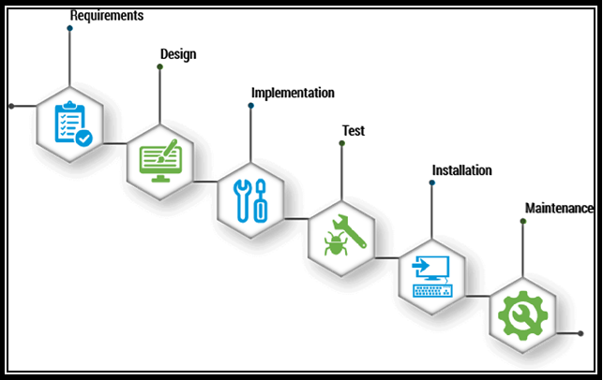

## *Security, Best Practices & Supported versions*

* + The License Web Application will be protected by **cyber security and vulnerability**.
  + The License Web Application will work on **desktop and laptop screens**; it is not mobile & tablet responsive. It will work on the latest versions of Google Chrome, Mozilla Firefox, and Safari.
  + The browser version at the time of UAT release will be considered as the latest support version.

# User Descriptions

|  |  |  |
| --- | --- | --- |
| **Sr. No** | **User Type** | **Activities in the system** |
| 1 | System User | - This user will **exist only in the database**, and the system will utilize this user's **ID** for data insertion or modification from the backend only.  - This user will not display in the License Web Application. **Example:** Data Ingestion |
| 2 | Super Admin | - This user will be the **main user** for the License Web Application. The source code will automatically configure the required information for this user, including roles and permissions, when deploying the application in a specific environment. - This user will have **full access.** |
| 3 | Sub-user | - A **sub-user** is a user created by an authorized user within the system.  - This user can be assigned **any existing or newly created role** by an authorized user.  - This user will have access to the application and its features **based on the assigned permissions**. |

# System Requirements

## *User Management > Users Page*

There has been provision in a system for their administrators to create & manage the users. Super Admin has system level access and can manage each of sub users, roles & their permissions.

The system has a provision for super admin/authorized users to create & update the sub user and its information who has access to it. This is very basic and essential information of sub users.

Those are the internal users which will access the License Web Application to manage customers & their licenses based on given rights / access permissions.

**Prototype:**

* The screen below illustrates the list of all created users, including options for Search, Add, Edit, and Delete:

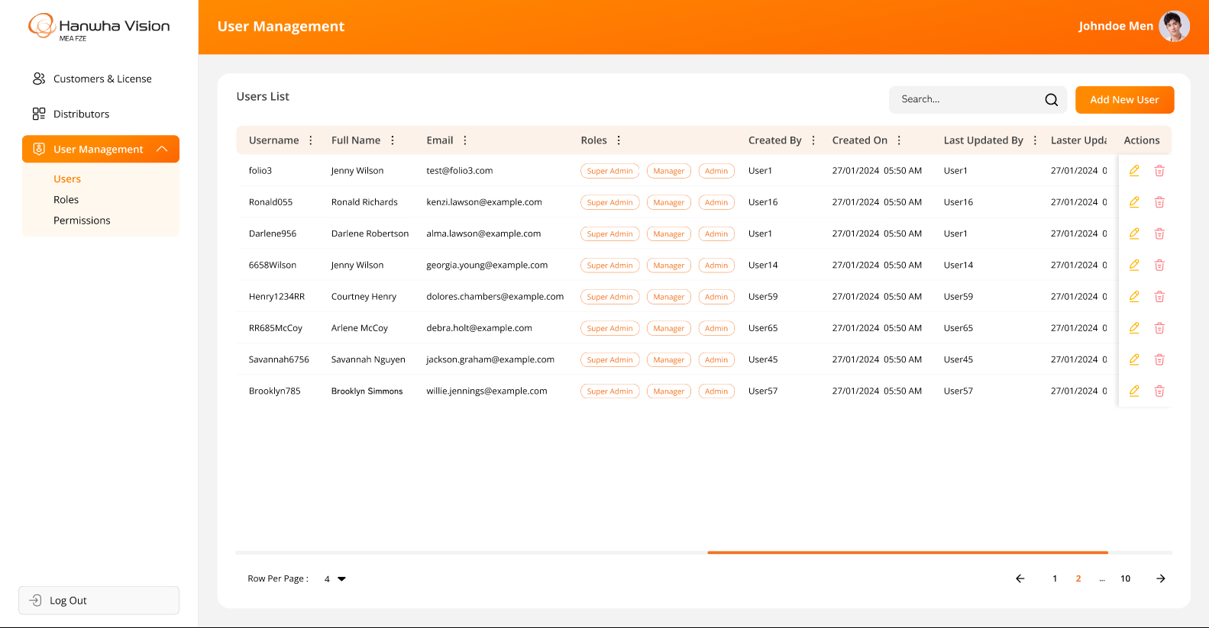

* The screen below represents the form for creating a new user in the License Web Application, allowing users to enter relevant details and submit the information:

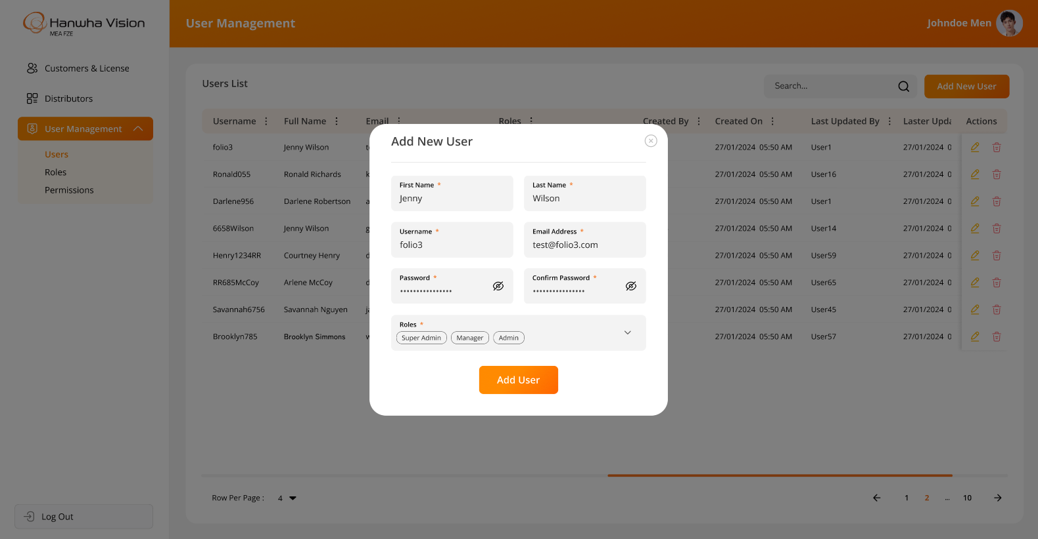

* The screen below displays the form for editing an existing user in the License Web Application, allowing users to modify relevant details and update the information. **Since** all users can change/reset their passwords independently, the "**Password**" and "**Confirm Password**" fields should be hidden while editing user details:

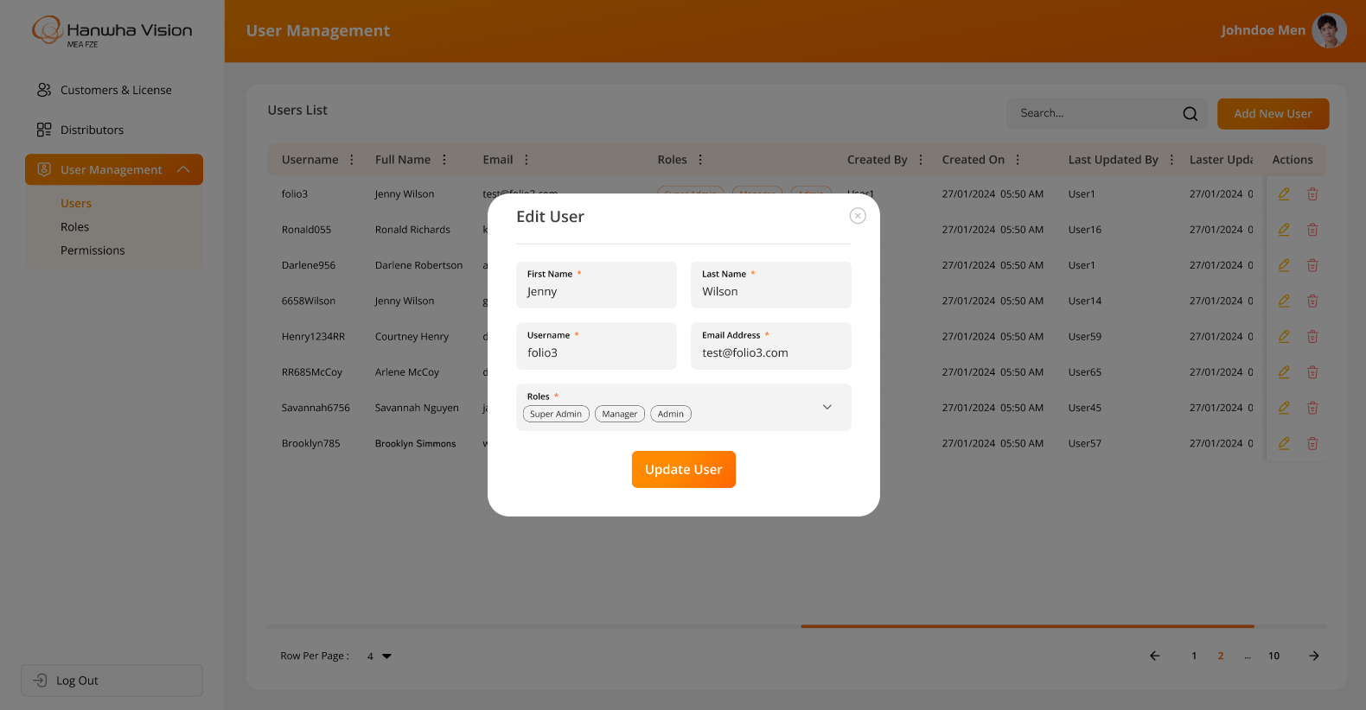

* The system will prompt for OTP verification when a user attempts to update the email address. OTP verification will not appear for other updates:

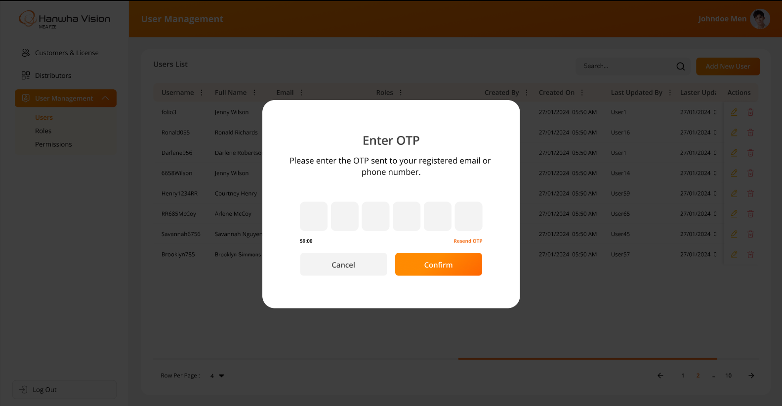

* The system will request confirmation when a logged-in user attempts to delete any user:

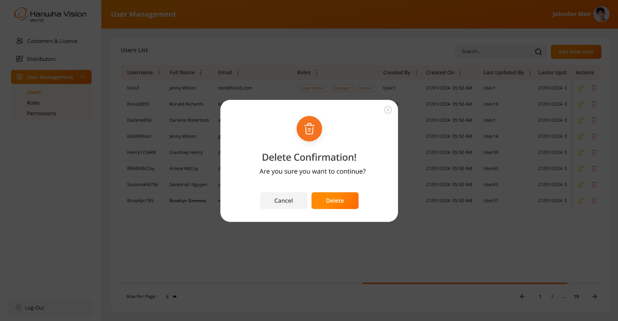

**Business Rules:**

* The system will display information and functionality **strictly as per the above attached screenshots**.
* The **authorized user** will have the ability to **create** and **update** sub-users.
* Password field will include following criteria:
  + Minimum password length: 8 characters
  + At least 1 uppercase letter
  + At least 1 lowercase letter
  + At least 1 numeric digit
  + At least 1 special character (excluding *)
* Email Address will be verified by sending email notification with the attachment of OTP. While adding or updating the user information.
* Authorized users will be able to **assign multiple roles** to the specific user.
* The “Add New User” screen will include following fields:
  + First Name*
  + Last Name*
  + Username*
  + Email Address*
  + Password*
  + Confirm Password*
  + Roles*
* The “Edit User” screen will include following fields:
  + First Name*
  + Last Name*
  + Username*
  + Email Address*
  + Roles*
* Since all users can change/reset their passwords independently, the "Password" and "Confirm Password" fields should be hidden while editing user details.
* The asterisk (*) indicates a mandatory field only.
* The system will **not allow duplicate email addresses or usernames**, as they must always be unique. These identifiers are essential for user authentication within the system.
* When a logged-in user attempts to delete another user, the system will prompt for confirmation. Once confirmed, the system will **soft delete** the user, meaning the record will remain in the database but will no longer be visible in the web application.
* The system will offer filter options (**like** **Sort By ASC, Sort by DESC, Filter, Hide Column, Manage Columns)** on specific columns using the MUI library, which is integrated into the entire web application. These filters will reset when the user reloads the page or navigates to another page.

**Data Dictionary:**



## *User Management > Roles Page*

The system provides functionality for the Super Admin/ authorized users to create and manage sub-user’s roles through the License Web Application. This page will be accessible only to authorized users.

**Prototype:**

* The screen below displays the list of all created roles, with options for Search, Add, Edit, and Delete:

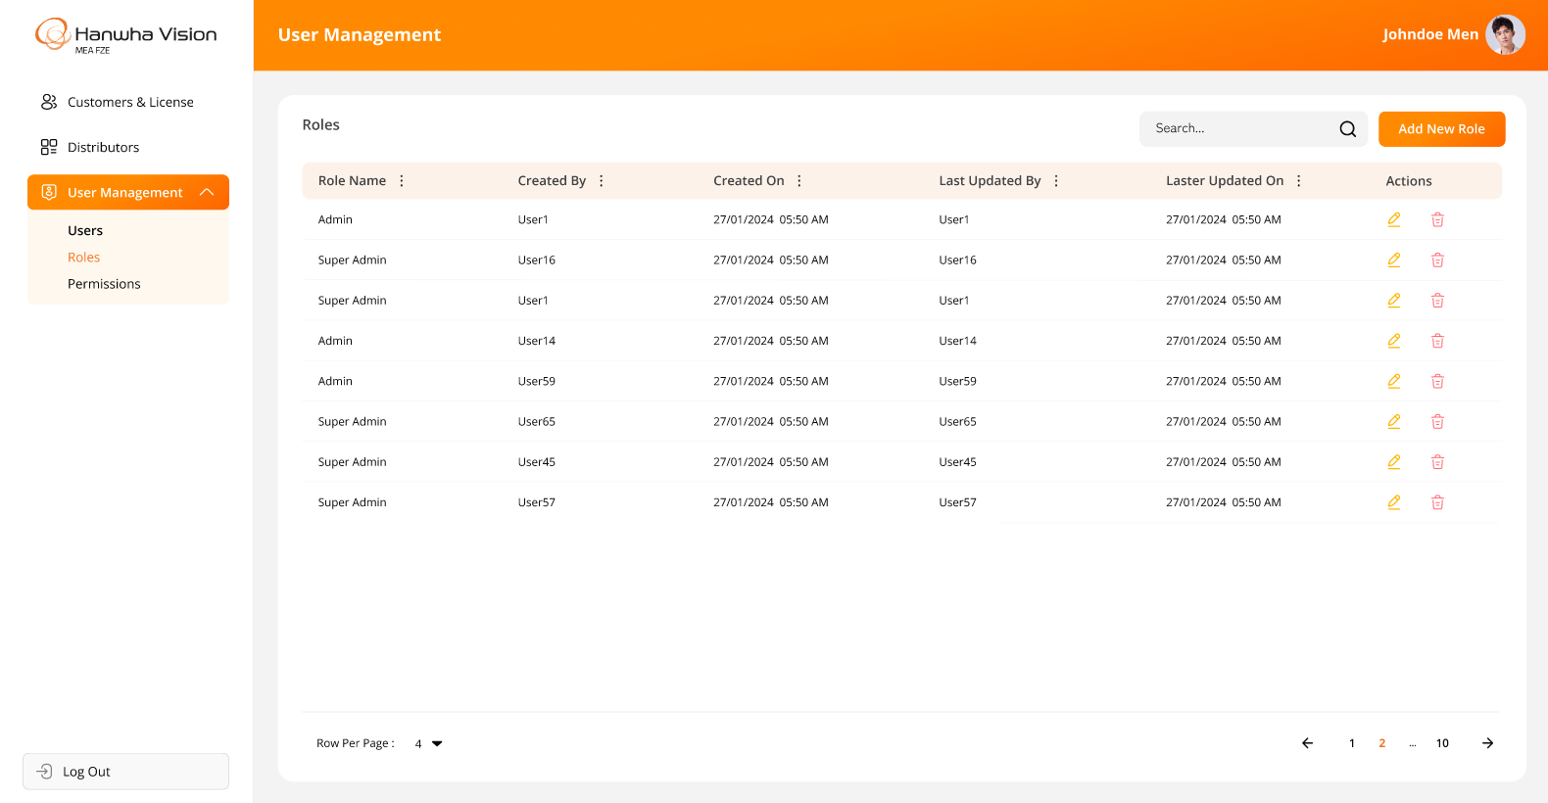

* The screen below represents the details for creating a new role in the License Web Application:

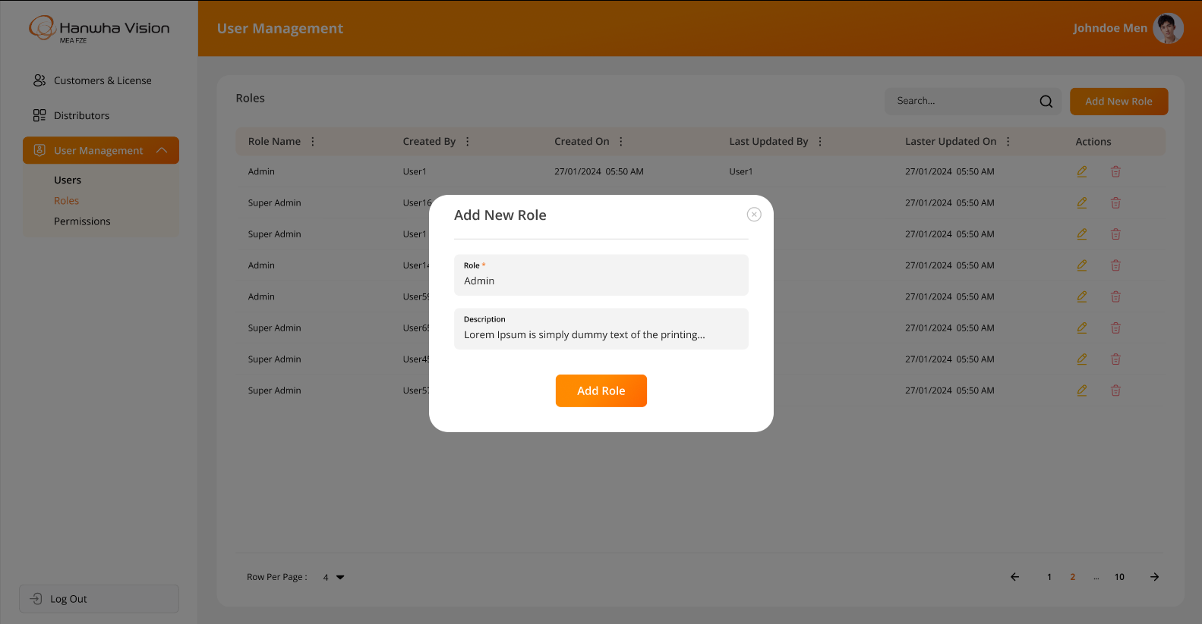

* The screen below represents the details for existing role while editing any specific role in the License Web Application:

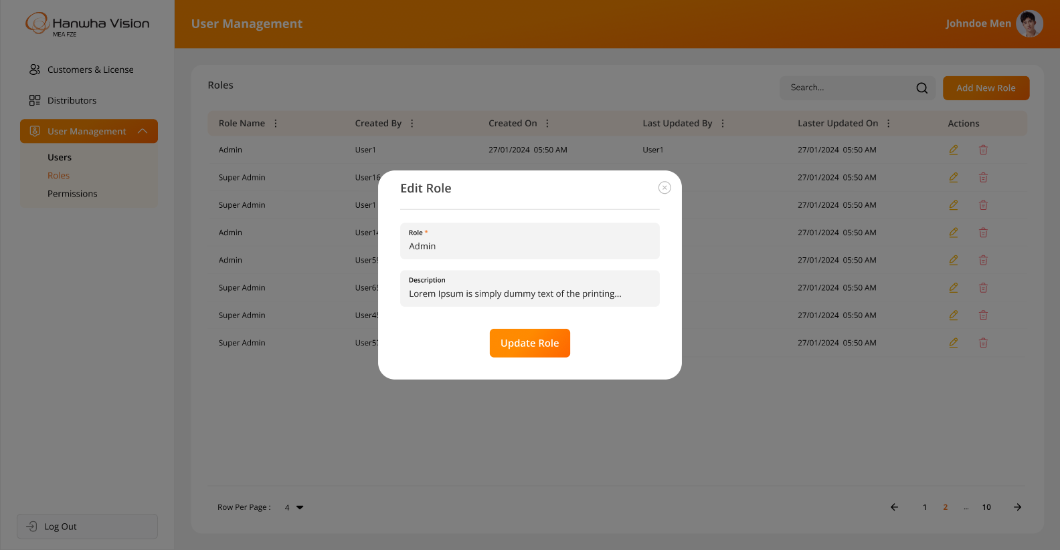

* The system will request confirmation when a logged-in user attempts to delete any role:

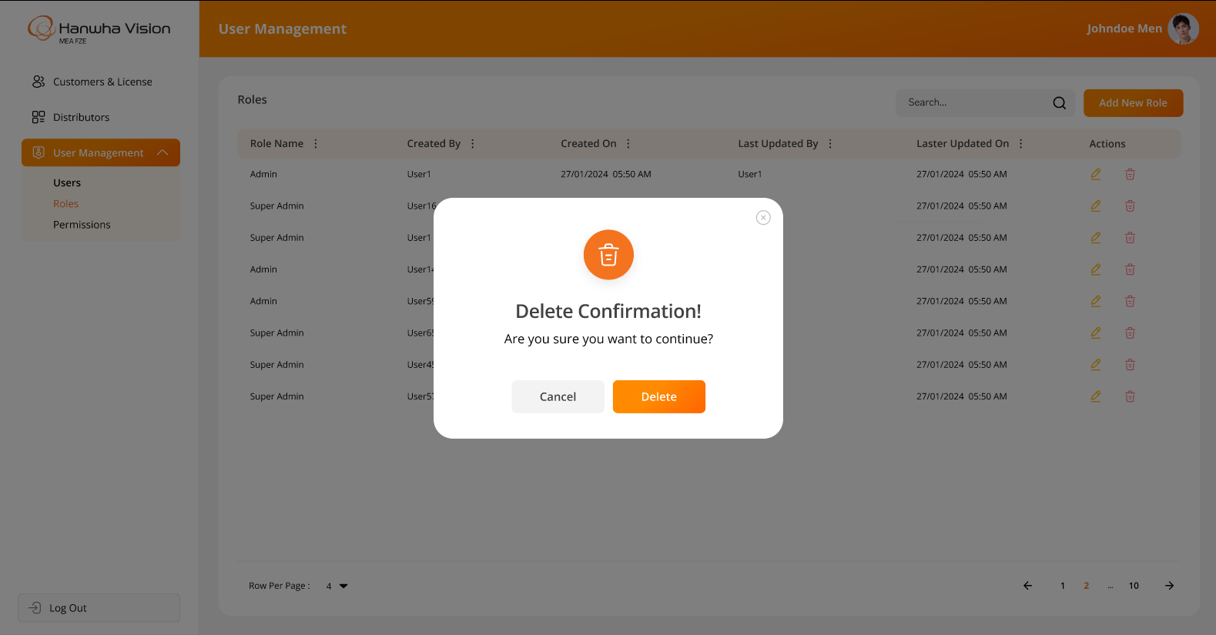

**Business Rules:**

* The system will display information and functionality **strictly as per the above attached screenshots**.
* Authorized users will have the ability to **create and update roles** within the system.
* The system will **not allow the deletion of a role** if it is already associated with any user.
* The system will **prevent duplicate entries** for roles or user-role assignments.
* When a logged-in user attempts to delete role, the system will prompt for confirmation. Once confirmed, the system will **soft delete** the user, meaning the record will remain in the database but will no longer be visible in the web application.
* The “**Add New Role**” & “**Edit Role**” screen will include following fields:
  + Role Name*
  + Description
* The asterisk (*) indicates a mandatory field only.
* The system will offer filter options on specific columns using the MUI library, which is integrated into the entire web application. These filters will reset when the user reloads the page or navigates to another page.

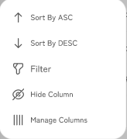

**Data Dictionary:**



## *User Management > Role Assignments to a Specific User*

There has been provision in the system for super admin/ authorized users to manage role assignments to the specific user from the License Web Application.

Once a role is defined, it is time to assign the responsibility to the respective users based on their designation and tasks.

This role assignment will be handled by super admin / authorized users. The system will allow access only according to the role assigned to the logged-in user.

**Prototype:**

* The screen below illustrates how an authorized user can assign one or multiple roles to a specific user while creating a new user from the Users Page:

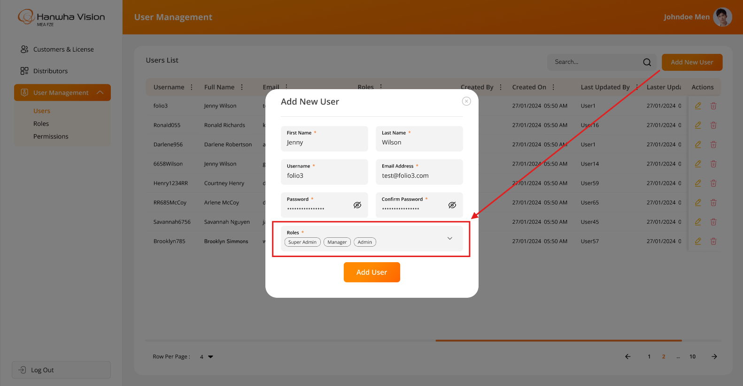

* The screen below illustrates how an authorized user can update or modify one or multiple roles for a specific user while editing their information from the Users Page:

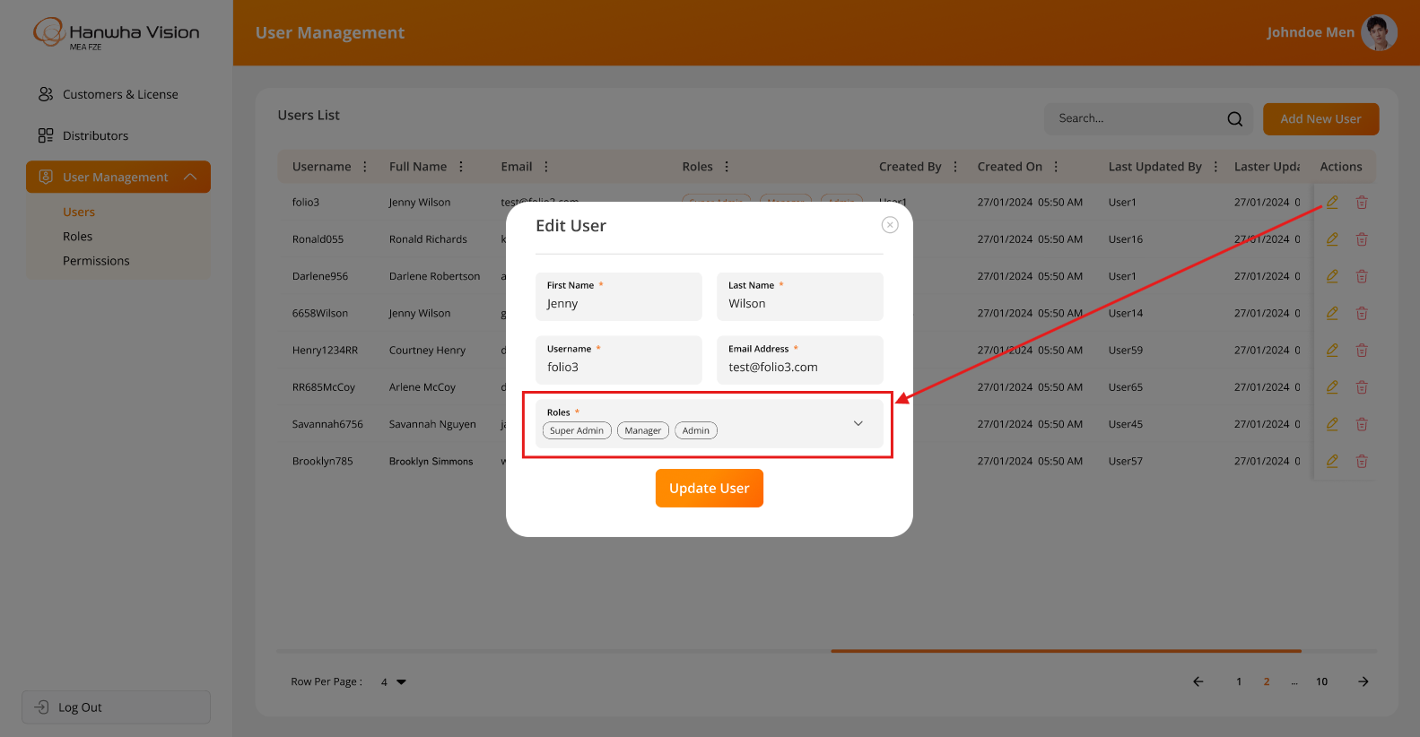

**Business Rules:**

* The system will display information and functionality **strictly as per the above attached screenshots**.
* Authorized users can select and assign specific roles from a dropdown list to any sub user.
* The super admin / authorized user can assign a single or multiple roles to a sub user, but this can only be done from the "Edit User" screen.
* Authorized users can **assign one or multiple roles** to a specific user from the **Users Page**.
* Authorized users can **update or modify user roles assignment** from the **Users Page**.
* Any changes to the role assignment will immediately be reflected after relogging to the user after they log out and log back into the system.

**Data Dictionary:**

* The system will store the selected unique **roleId(s)** from the **roleMaster** table in the **userMaster** table. Refer to the highlighted row in GREEN in the image below for reference:



## *User Management > Permissions Page*

The system provides a feature to assign permissions at the screen level with various types of access, such as add, update, delete, and view etc.

The authorized user can create roles with specific screen-level permissions and assign them to sub users. When a user logs in, they will only have access to the functionalities permitted by their assigned role. This screen will provide the ability to the authorized user to update selected role wise permissions for the specific screen(s) or action(s).

**Prototype:**

* The screen below illustrates how an authorized user can configure permissions for each role within the system.

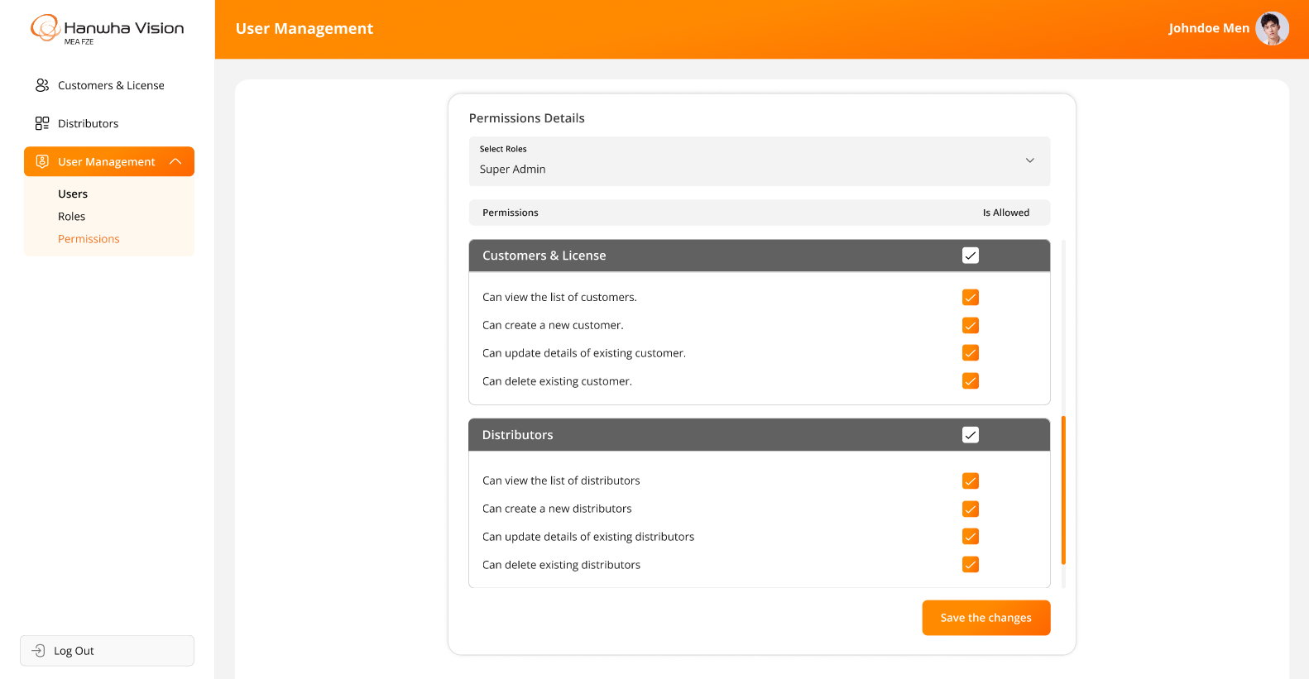

**Business Rules:**

* The system will display information and functionality **strictly as per the above attached screenshot**.
* Authorized users can assign or update permissions for specific roles, defining access to various system functionalities.
* The system will ensure that permissions are role-based and cannot be assigned to individual users directly.
* The system will prevent the deletion of a role if it is already assigned to any user.
* The system should allow access only on those screens / actions which are allowed against the assigned role for logged in sub user.
* The super admin user will have full access to the admin application.
* The super admin / authorized user can assign screen-level permissions and corresponding actions (e.g., add, update, delete, view) to roles. However, the super admin / authorized user cannot assign permissions to actions that are not applicable to specific screens (**For example**, *Insert/Update/Delete rights are not applicable to screens like Profile or Change Password. Therefore, the system should restrict the* super admin / authorized *user from assigning these permissions to roles for such screens)*
* The super admin / authorized user will be able to update roles at any point of time.
* The system will maintain the history of each change.
* Any updates to role permissions will immediately be reflected after relogging for all users associated with that role.

**Data Dictionary:**



* An example of the **screenMaster** table is attached below to provide better clarity on the backend implementation:

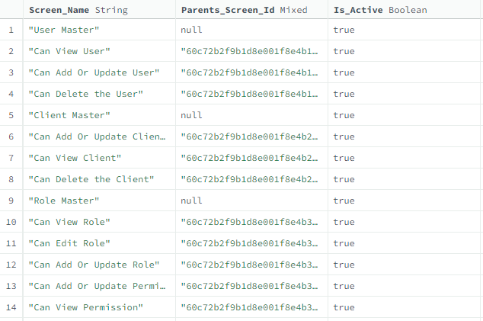

The above table contains a list of permissions that exist in the system, categorized by pages and their respective actions.

**For example,** the **User Creation screen** will have **View, Add, Edit, and Update** actions. Therefore, the following entries will exist in the table for the **Users screen**:

|  |
| --- |
| **User Master** |
| -> Can view user list |
| -> Can edit user details |
| -> Can add or update user details |
| -> Can delete user |

**Role & Screen Mappings:** The table below provides information on screen-wise permissions assigned to specific roles:



## *Login Page*

There has been provision in the system for all their internal users to login into the License Web Application.

This page will validate the user’s credentials when any user tries to login into the system by entering their credentials.

**Prototype:**

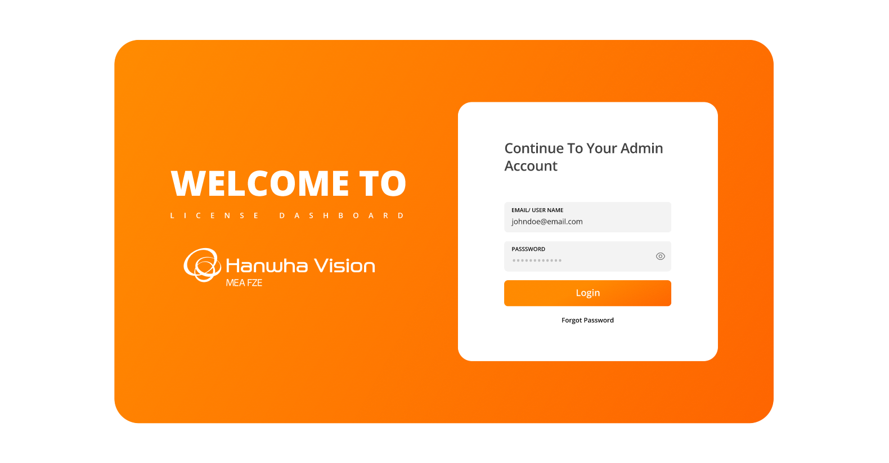

**Business Rules:**

* The system will display information and functionality **strictly as per the above attached screenshot**.
* The **login screen** will include a logo and text fields for entering the **username or email address** and **password**, along with a **Login (Submit)** button as well as “Forgot Password” link.
* Upon clicking the "Forgot Password" link, the user will be redirected to the Forgot Password screen, where they can enter their registered email address and reset their password.
* Upon clicking the “Login” button, the application will validate the **entered username or email address** and **password**.
* If the credentials are successfully validated:
  + The application will check the user's authorizations and redirect them to the **Customers & Licenses** **screen**.
* If the entered credentials are invalid:
  + The system will display an appropriate error message on the login screen.
* If the user is marked as **Inactive/Deleted** in the system:
  + They will not be able to login using their existing credentials.
  + In such cases, the user must contact the **respective active & authorized users** of the **Administrator Team** for further assistance.
* The system will validate below highlighted fields while logging into the system.

**Data Dictionary:**



## *Forgot Password Page*

The License Web Application includes a provision that allows all their internal users to reset their passwords if they forget it.

This screen is designed for registered users who have lost or forgotten their passwords. It enables them to regenerate/reset a new password easily.

**Prototype:**

* The screen below illustrates the Forgot Password page, where users can enter their registered email address and proceed with resetting their password in case it is forgotten or lost:

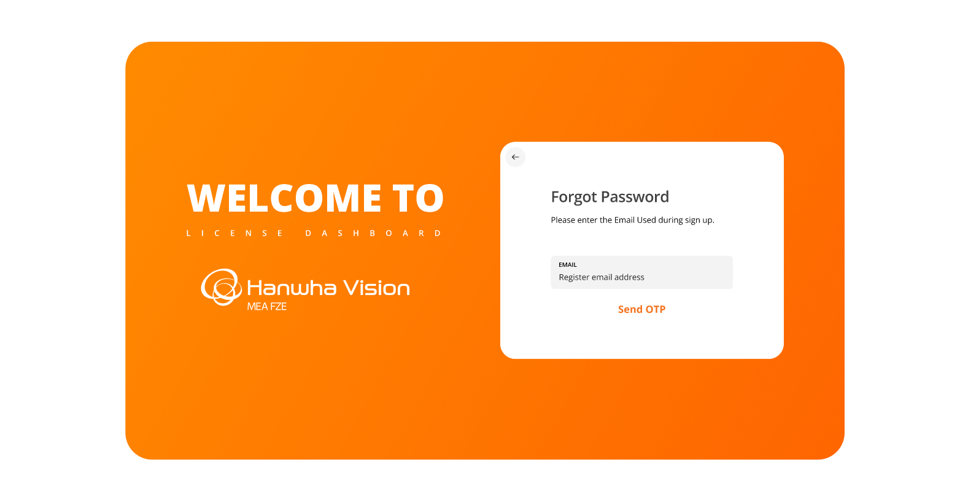

* The screen below illustrates the "Enter OTP" page, where users must enter the OTP received on their registered email address to verify their identity. Upon entering the OTP and clicking the "Submit" button, users will be able to proceed with resetting their password in case it is forgotten or lost. This screen also includes a "Resend OTP" option, allowing users to request a new OTP if they do not receive one within 1 minute or the configured time limit:

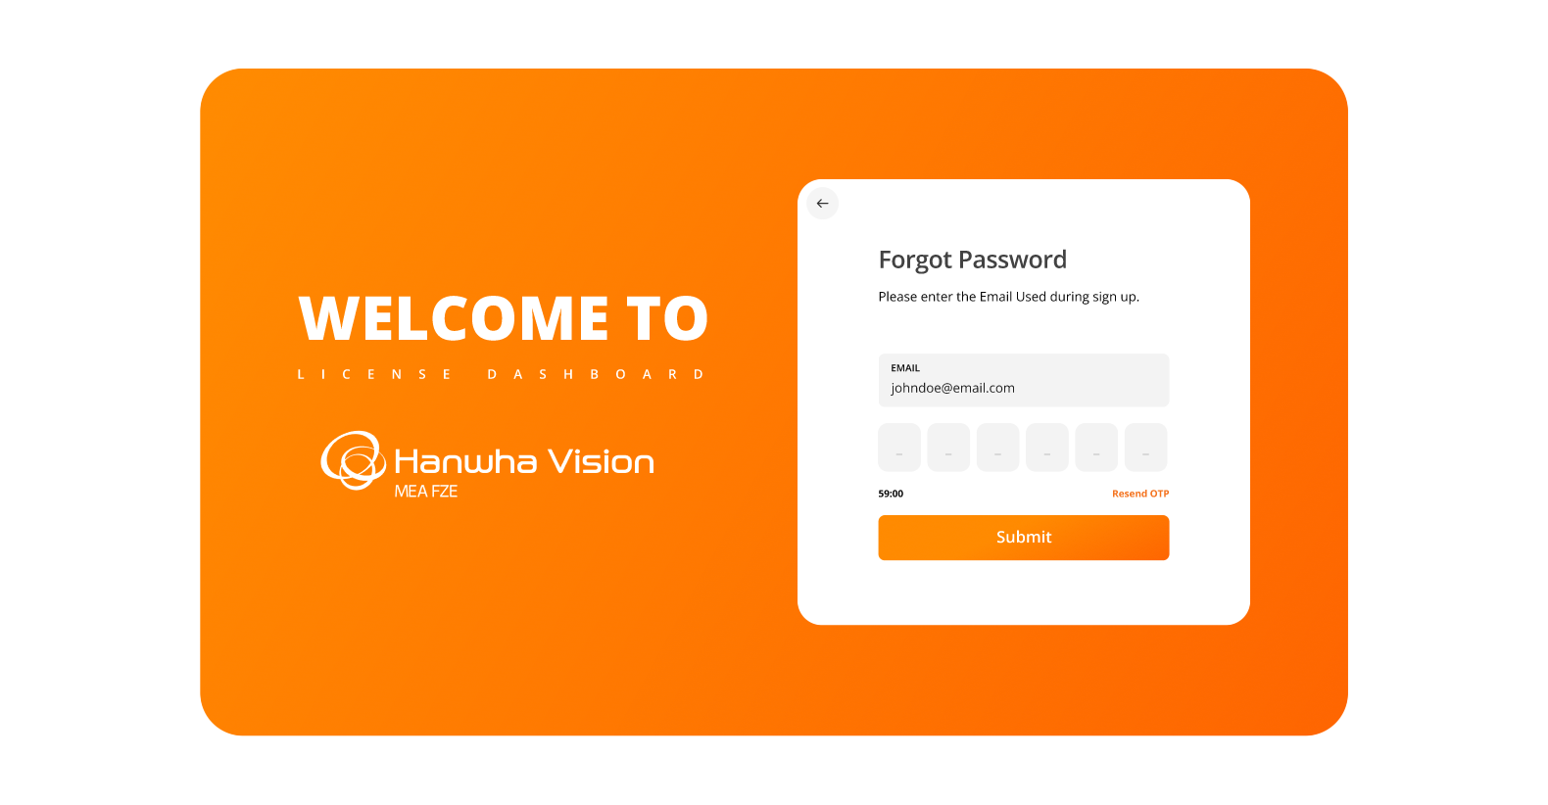

* Upon entering the OTP and clicking the "Submit" button, if the entered OTP is verified successfully, users will be redirected to the password reset page. On this page, users must enter a new password and confirm password to complete the password reset process:

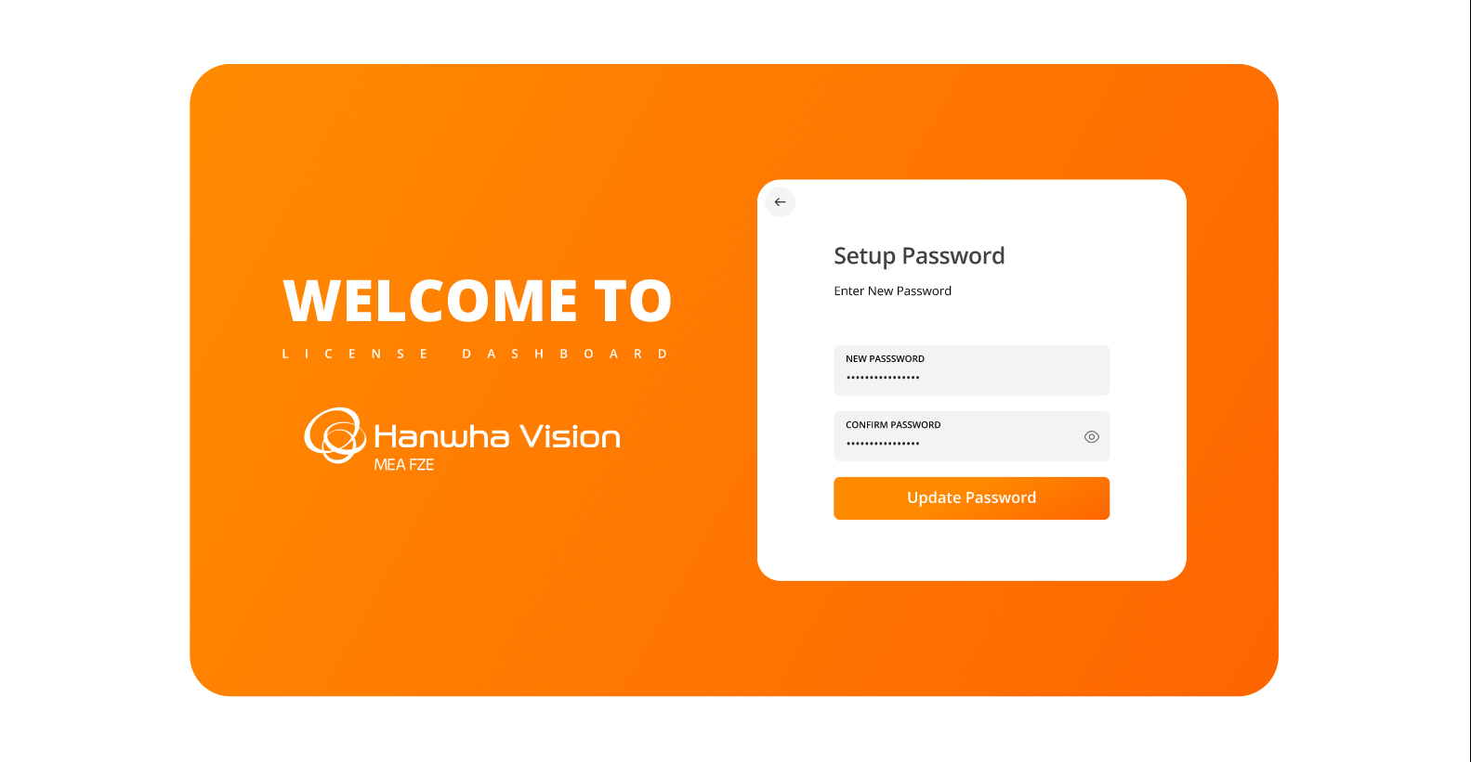

* The following success message will appear once the new password has been successfully updated in the system:

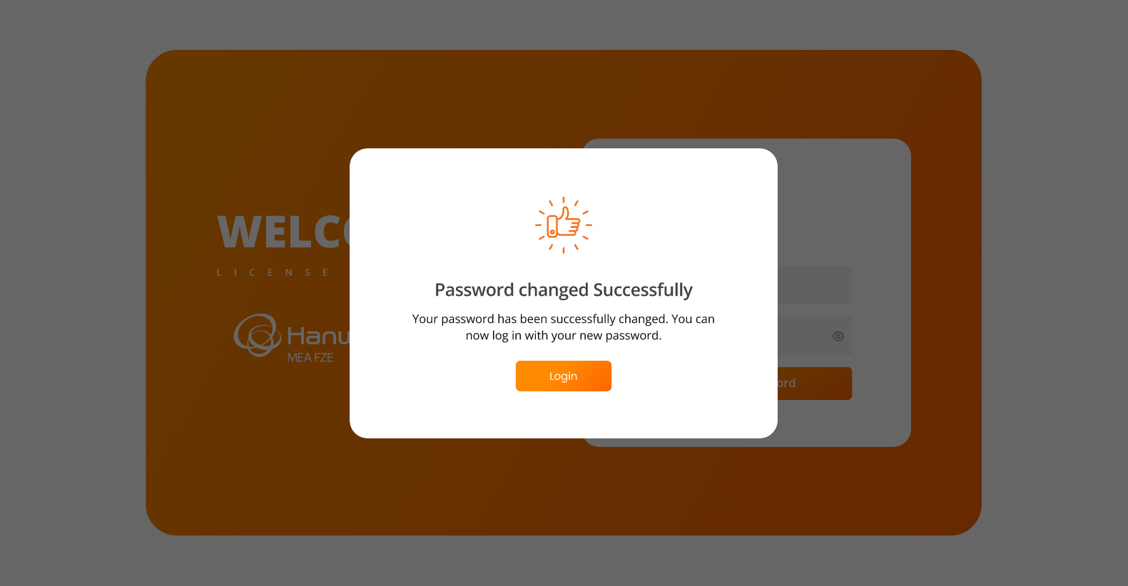

**Business Rules:**

* The system will display information and functionality **strictly as per the above attached screenshots.**
* The **Forgot Password** screen will include a logo and a text field for entering the registered email address.
* Upon clicking the **Generate OTP** button:
  + The user will receive an email containing an **OTP** to reset their password.
* After entering the OTP and clicking the **Submit** button:
  + The system will validate the OTP.
  + On successful OTP validation, the user will be redirected to the **Reset Password** screen.
* On the **Reset Password** screen:
  + The user will need to enter the **New Password** and **Confirm Password** fields.
  + Clicking the **Submit** button will update the user's password to the newly entered one in the system.
  + If the password is successfully updated in the system, the user will receive an appropriate success message on the screen. In case of failure, an error message will be displayed indicating the issue.
* After changing the password:
  + The admin user will be redirected to the **Login** page, where they will be able to log in using the new password.

**Data Dictionary:**



The system will utilize the above table for OTP verification during the forgot password process and update the **Password** field in the **userMaster** table (*refer to the data dictionary table under the “Users Page” section above*).

**Note:**

* After successfully resetting the password, the **OTP** will be marked as **isUtilized**, ensuring it cannot be used again.
* The **OTP** will remain valid for authentication only until the predefined **expiredOn** date and time.

## *Menu Items for License Web Application*

The system allows all admins to log in to the License Web Application and access the following menus and options:

**The following options/menus will be displayed on the sidebar:**

* Customers & Licenses
* Distributors
* User Management
  1. Users
  2. Roles
  3. Permissions
* Logout

**The following options/menus will be displayed when the user clicks on their profile image in the top right-hand corner:**

* Profile
* Change Password
* Logout

**Prototype:**

* The screen below illustrates above mentioned menu items & options for License Web Application.

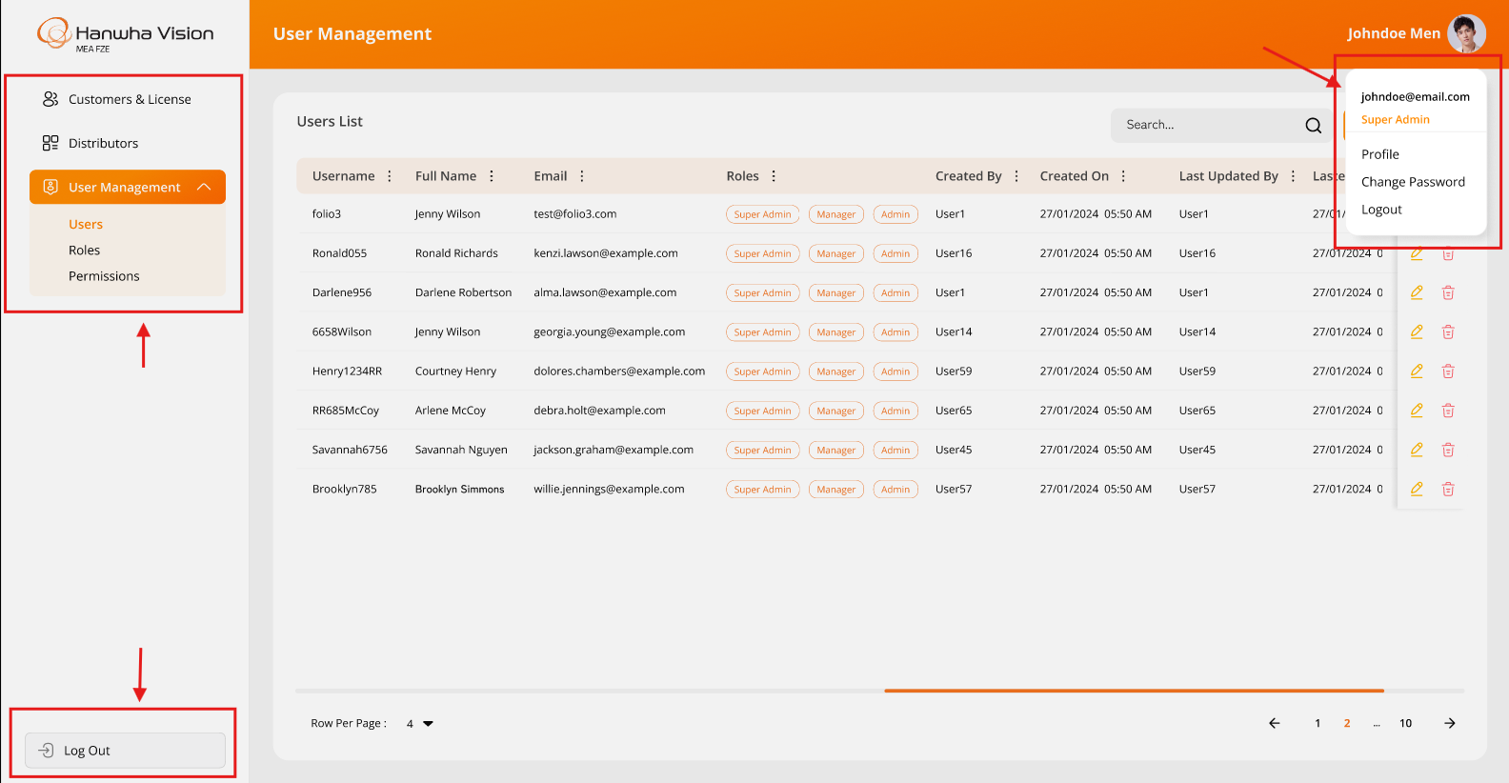

**Business Rules:**

* The system will display information and functionality **strictly as per the above attached screenshot**.
* The **logged-in** user will be able to access the above highlighted menus or options based on the specific assigned permissions only.
* All users will be able to access the following options:
  + Profile
  + Change Password
  + Logout
* The system will hide any menus that are not allowed for the specific logged-in user according to their assigned permissions.

**Data Dictionary:**

* *It is not required to manage any data dictionary for menu items, as it will be handled directly in the frontend code only*.

## *Profile Page*

The system provides a feature for all users to log in to the License Web Application and access the Profile page.

This page displays details specific to the logged-in user only.

This screen can be accessed by clicking on the **Profile** link located at the top-right corner of the screen's top bar.

**Prototype:**

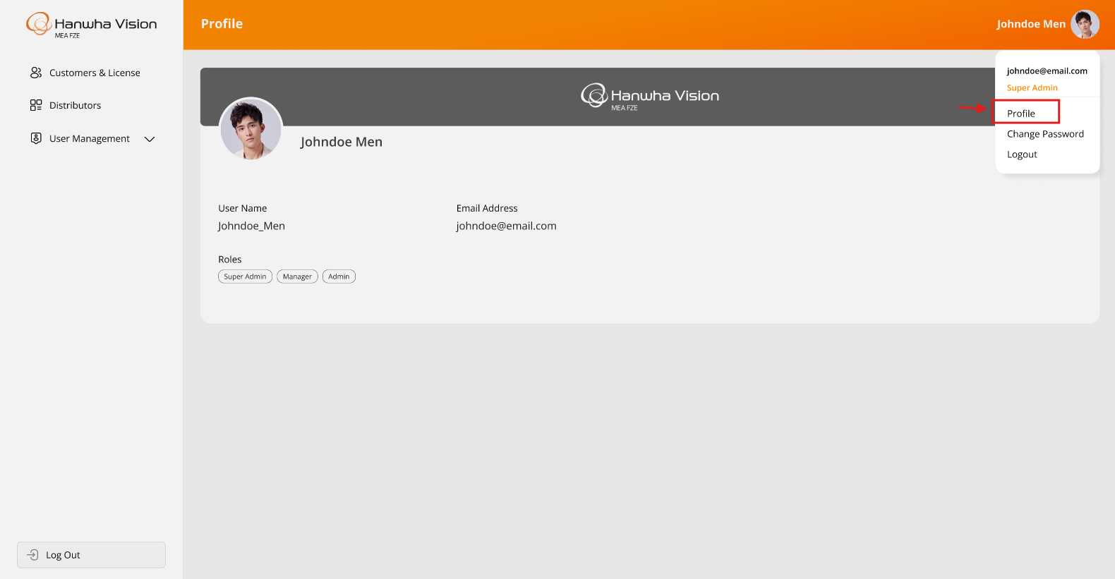

**Business Rules:**

* The system will display information and functionality **strictly as per the above attached screenshot**.
* The system will display information related to the logged-in user on this page. Which are enlisted below:
  + Profile Image
  + Full Name (*First & Last Name*)
  + Username
  + Email Address
  + Roles (*which is assigned to logged-in user from the Users screen)*
* This screen will allow logged-in users to only view their details except updating their profile image only.
* The user can update their **profile picture** by clicking on the current profile image and selecting a new one & the updated profile picture will be reflected across the entire system **after re-logging in.**

**Data Dictionary:**

* *This page will display registered information for the specific logged-in user from the* ***userMaster*** *table only*.

## *Change Password Page*

This screen allows all users to reset their existing password. The screen can be accessed by clicking on the **Change Password** link located at the top-right corner of the screen's top bar.

**Prototype:**

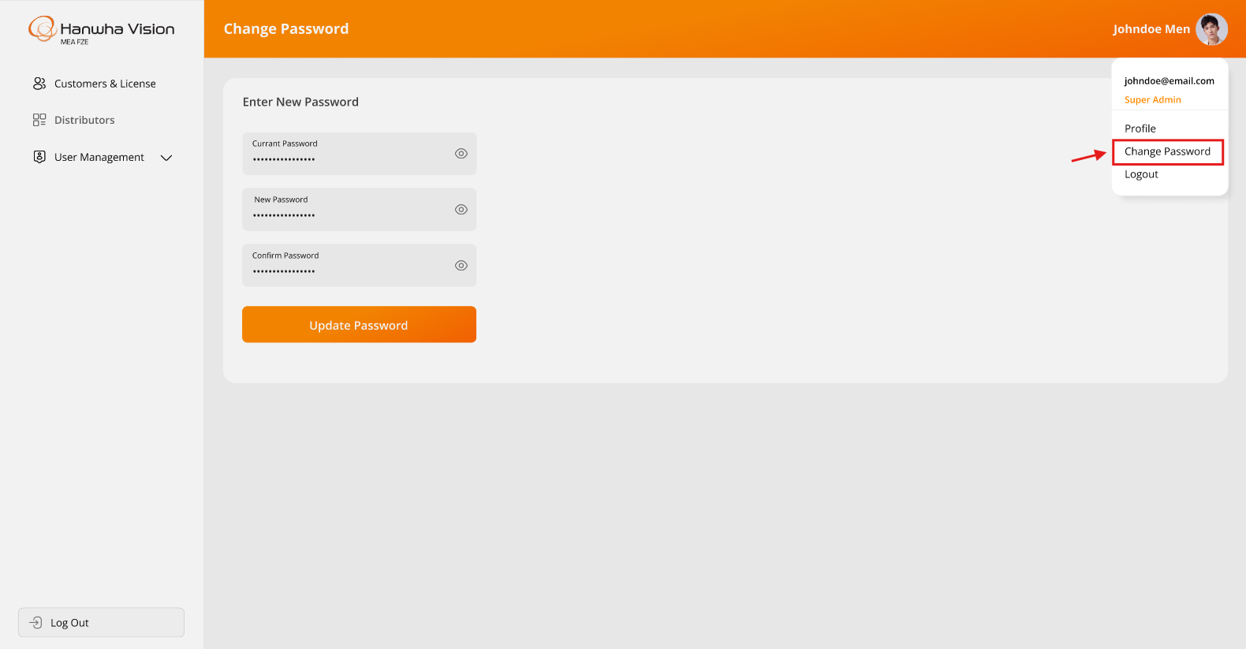

* The screen below illustrates the message that will appear once the password has been successfully changed in the system:

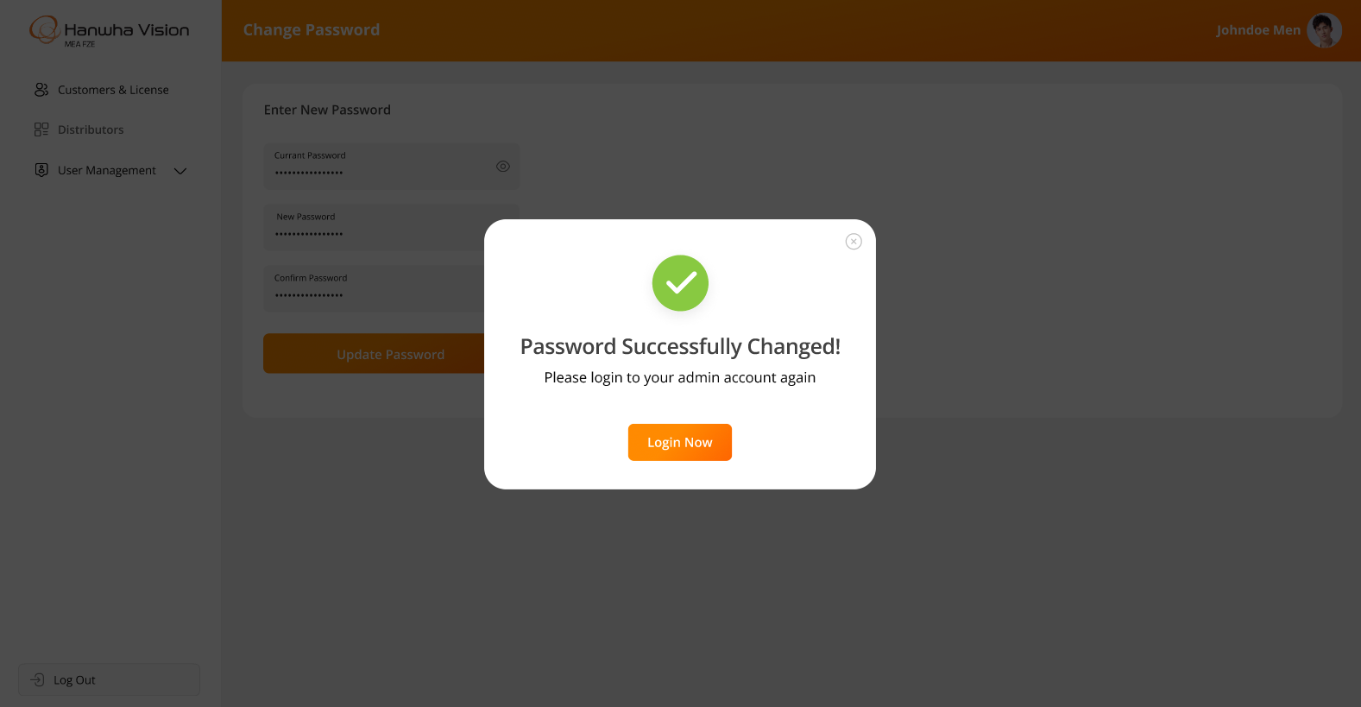

**Business Rules:**

* The system will display information and functionality **strictly as per the above attached screenshots**.
* All users will have access to this page.
* Users will be required to enter the following:
  + Old Password
  + New Password
  + Confirm Password
* Upon clicking the **Submit** button, the system will validate the entered old password:
  + If the old password is valid:
* The new password will be updated in the system.
* The logged-in user will be logged out from the License Web Application.
* The user must log in again using the newly created password.
  + If the old password is invalid:
* The system will display an appropriate error message to the user.
* Once the password has been successfully updated, the system will send an email to the user confirming the password change.

## *Distributors Page*

The system provides a feature for authorized users to create and manage distributors through the License Web Application. This page will be accessible exclusively to authorized users only, with actions such as adding, editing, and deleting distributors displayed based on the permissions assigned to each admin user.

**Prototype:**

* The screen below illustrates the list of all created distributors, including options for Search, Add, Edit, and Delete:

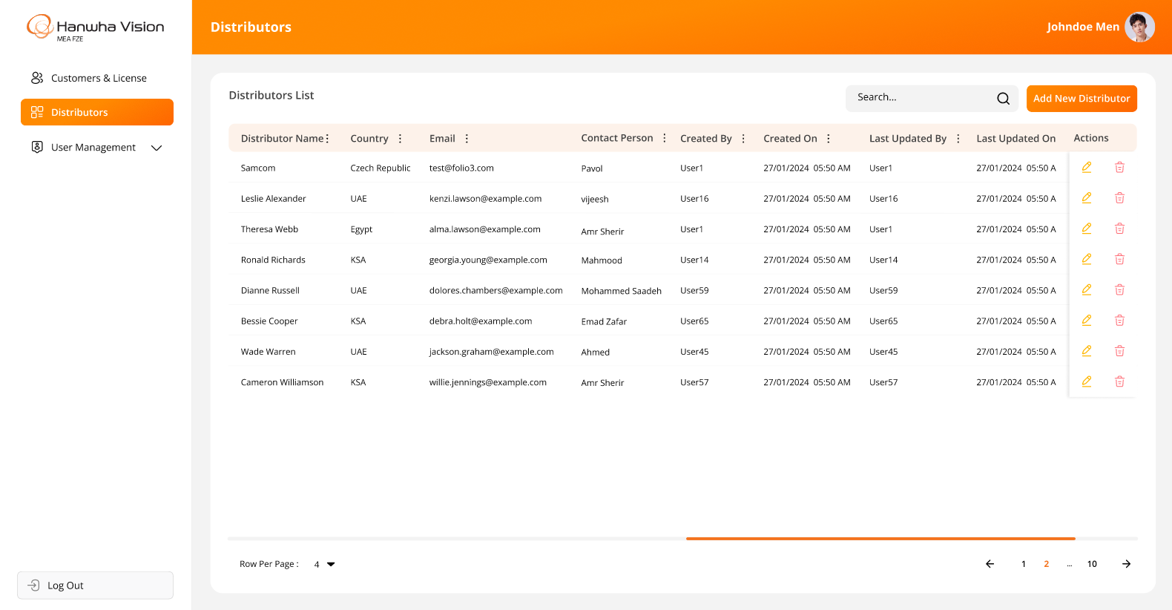

* The screen below represents the form for creating a new distributor in the License Web Application, allowing users to enter relevant details and submit the information:

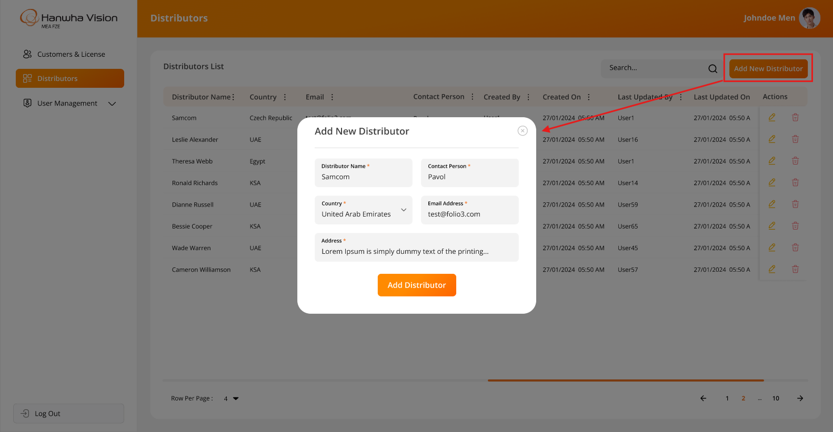

* The screen below displays the form for editing an existing distributor in the License Web Application, allowing users to modify relevant details and update the information:

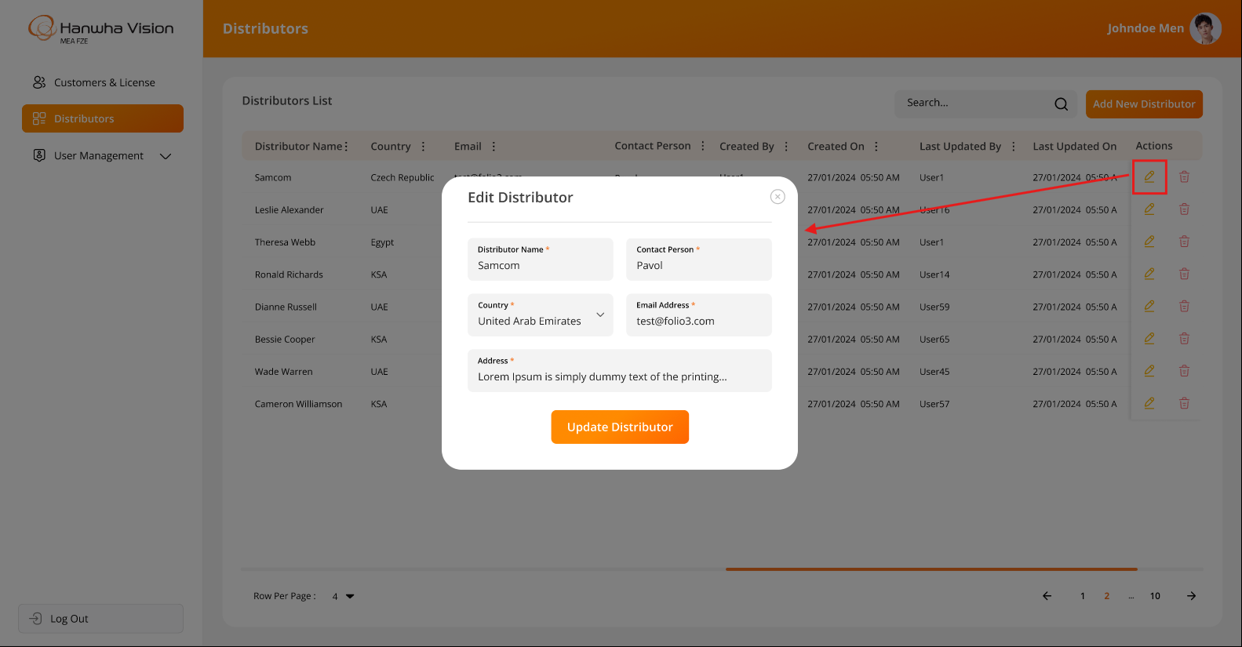

* The system will prompt a confirmation message when a user attempts to delete a distributor, ensuring that the action is intentional before proceeding:

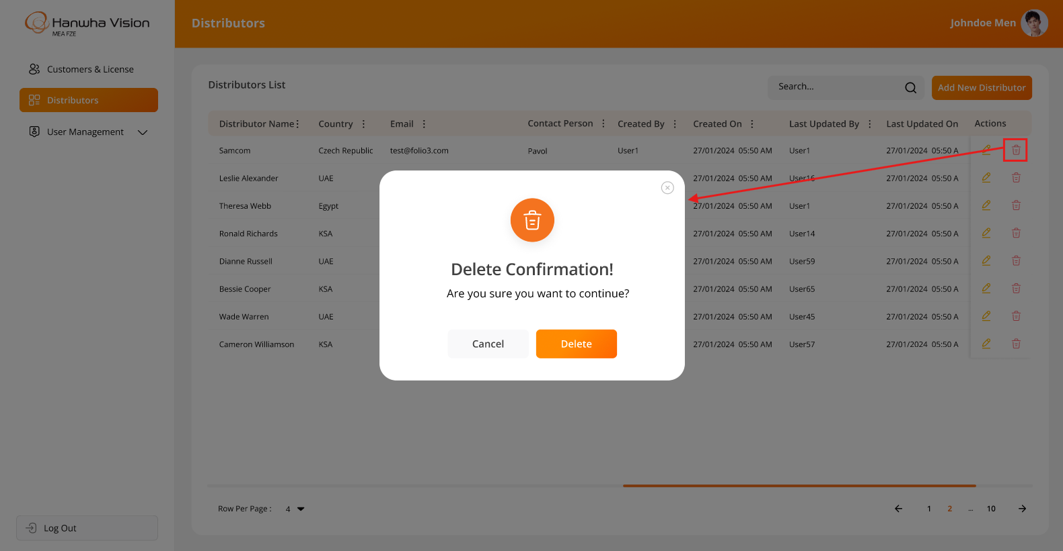

**Business Rules:**

* The system will display information and functionality **strictly as per the above attached screenshots.**
* Authorized users will have the ability to **create and update** distributors within the system.
* The system will not allow users to delete a distributor if the distributor is associated with any active customer.
* The system will **prevent duplicate entries** for distributors by validating the **distributor name**.
* When a logged-in user attempts to delete distributor, the system will prompt for confirmation. Once confirmed, the system will **soft delete** the distributor, meaning the record will remain in the database but will no longer be visible in the web application.
* The “Add New Distributor” & “Edit Distributor” screen will include following fields:
  + Distributor Name*
  + Contact Person*
  + Country*
  + Email Address*
  + Address*
* The asterisk (*) indicates a mandatory field only.
* The system will offer filter options on specific columns using the MUI library, which is integrated into the entire web application. These filters will reset when the user reloads the page or navigates to another page.

**Data Dictionary:**



## *Customers & Licenses Page*

The system includes a provision for the authorized users to create and manage customers through the License Web Application.

It will also provide an ability to manage customers wise their license details.

This page will be accessible only to authorized users, and actions such as adding, editing, and deleting customers & their licenses will be displayed based on the logged-in user's assigned permissions.

**Prototype:**

* The screen below illustrates the list of all created customers, including options for Search, Add, Edit, Delete, and View License Details for a specific customer:

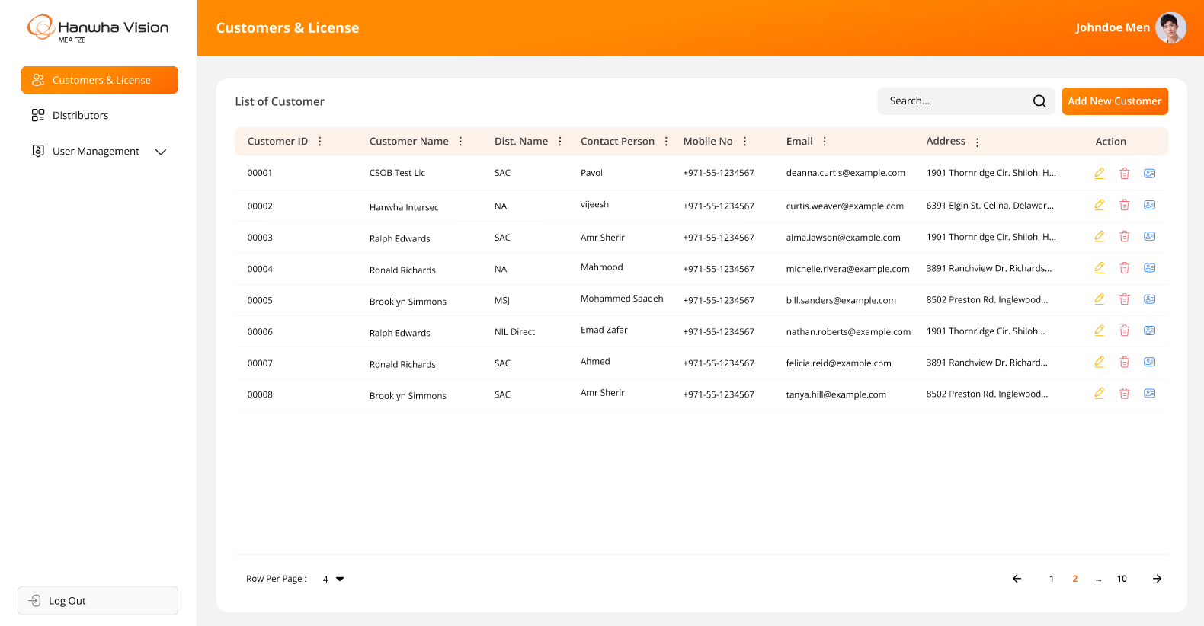

* The screen below represents the form for creating a new customer in the License Web Application, allowing users to enter relevant details and submit the information:

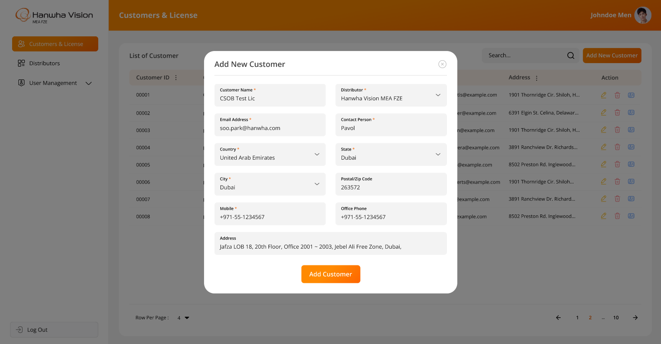

* The screen below displays the form for editing an existing customer in the License Web Application, allowing users to modify relevant details and update the information:

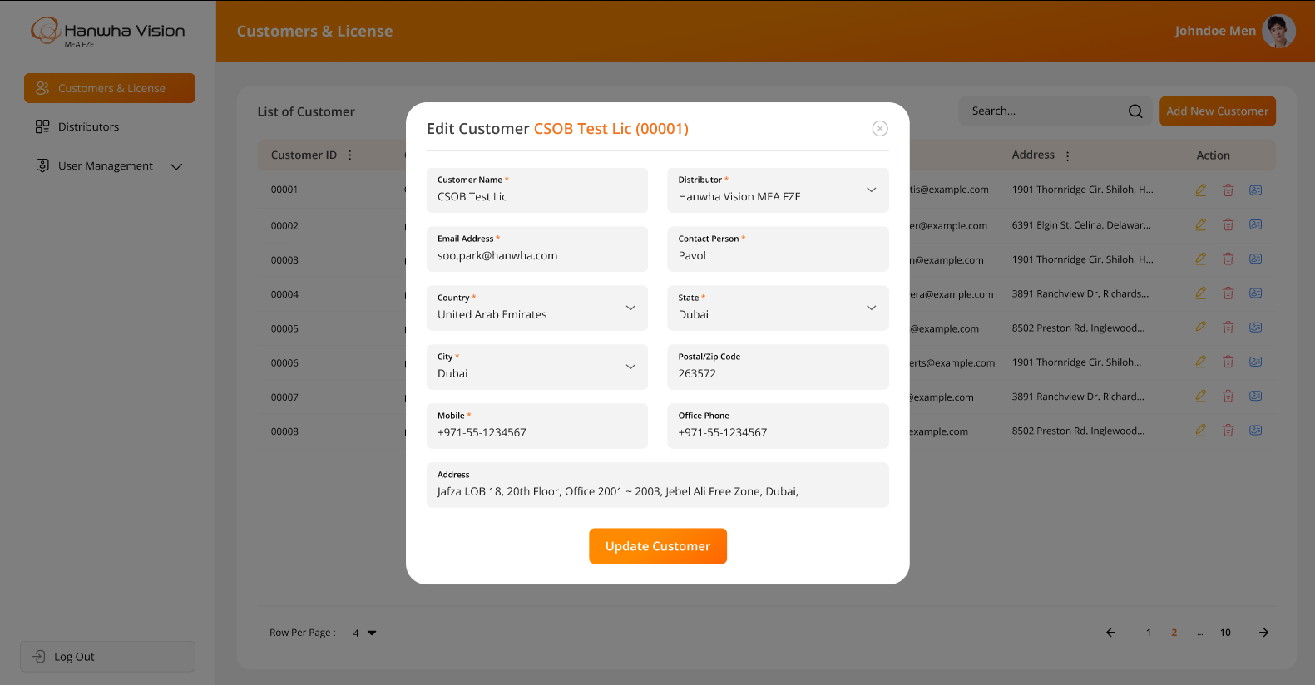

* The system will prompt a confirmation message when a user attempts to delete a customer, ensuring that the action is intentional before proceeding:

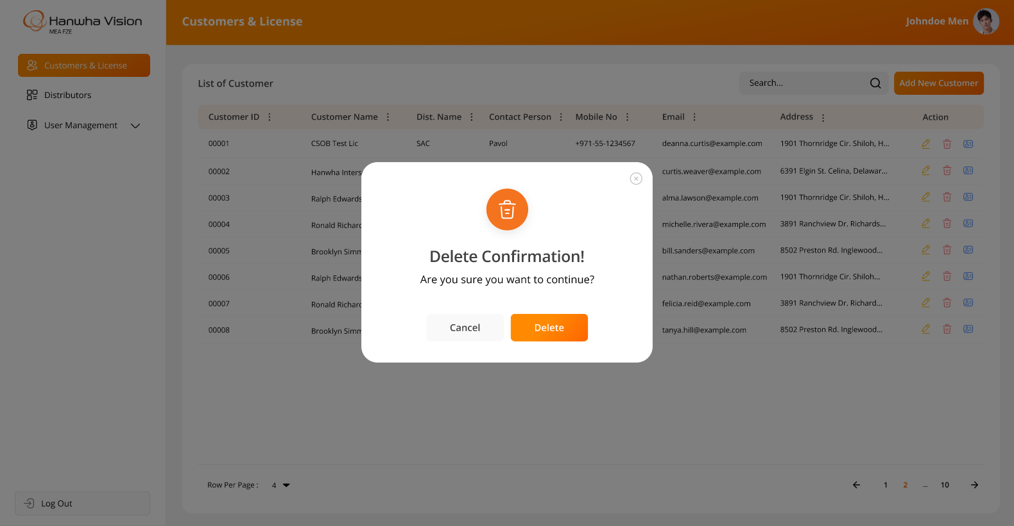

* The screen below illustrates the license details for the selected customer when no licenses exist in the system. From this screen, authorized users can create a new license for the specific customer:

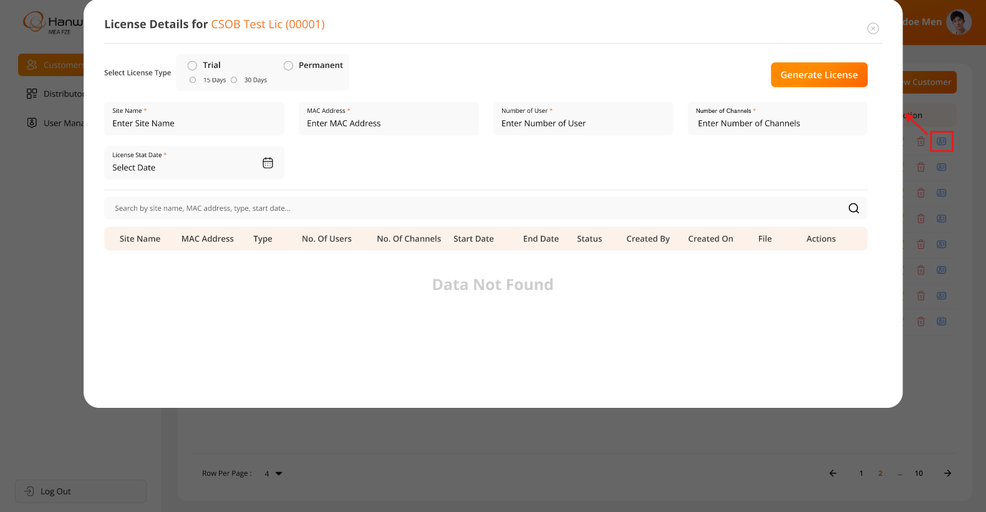

* The screen below illustrates the fields displayed when the user selects the **Trial License**, along with a list of existing licenses and their accurate status for the specific selected customer only, if any:

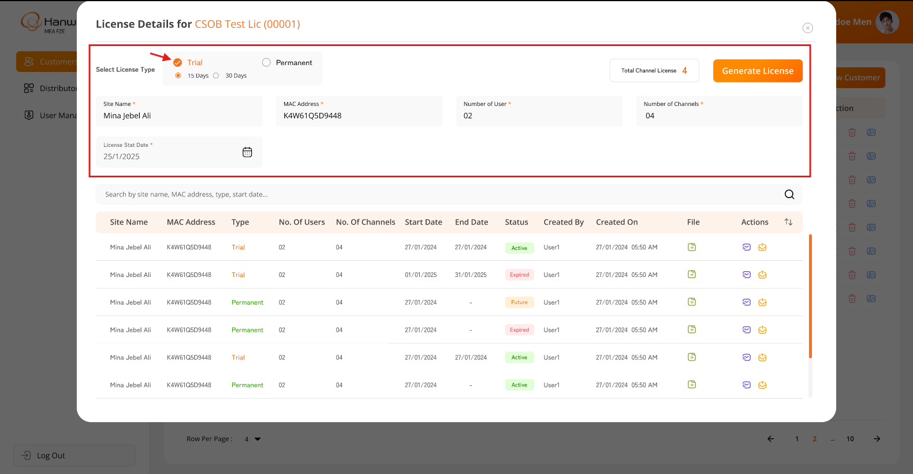

* The screen below illustrates the fields displayed when the user selects the **Permanent License**, along with a list of existing licenses and their accurate status for the specific selected customer only, if any:

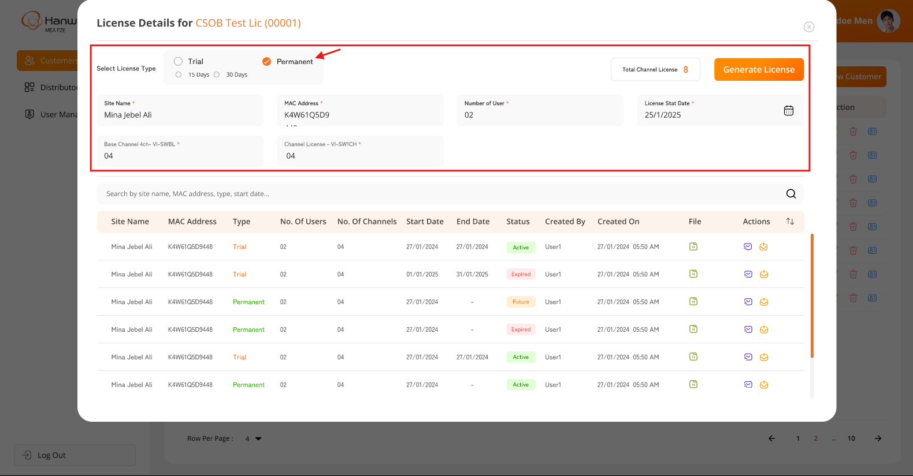

* The screen below illustrates the **list of all created licenses** for the specific customer, including options for **Search**, **Download File**, **Resend File**, and **Upgrade License** Details for a specific license associated with the selected customer only:

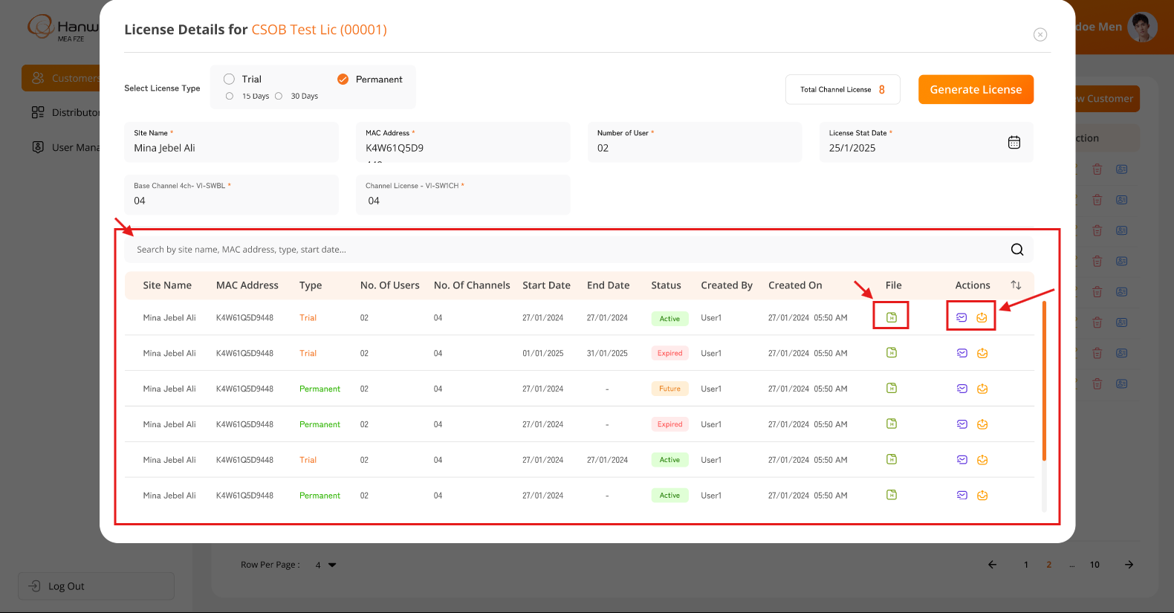

* The screen below illustrates the **message** that will be displayed when the user fills in the required details while creating or upgrading a license and clicks on the highlighted “**Generate license**” button. Once the user clicks on the “**Proceed**” button, the system will send an email to the displayed or associated distributor with the attached license file:

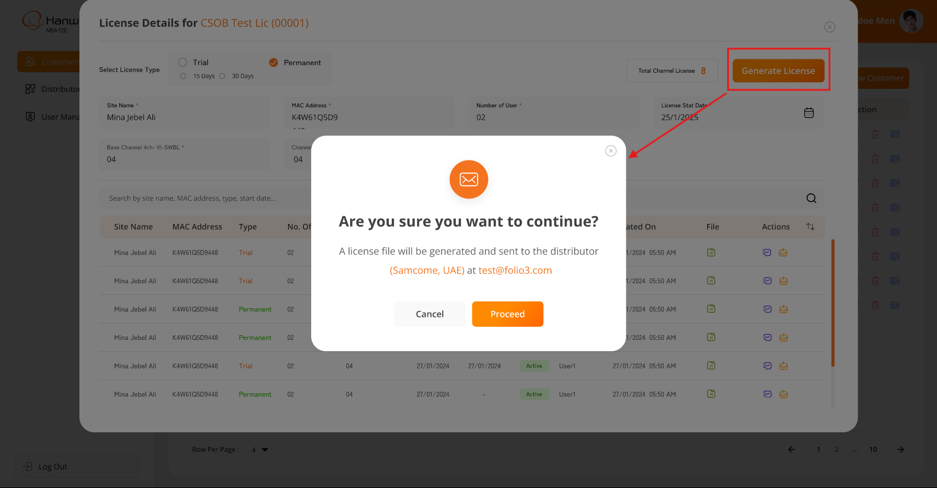

* The screen below illustrates the **message** that will be displayed when the user clicks on the highlighted “**Resend**” button. Once the user clicks on the “**Proceed**” button, the system will send an email to the displayed or associated distributor with the attached license file:

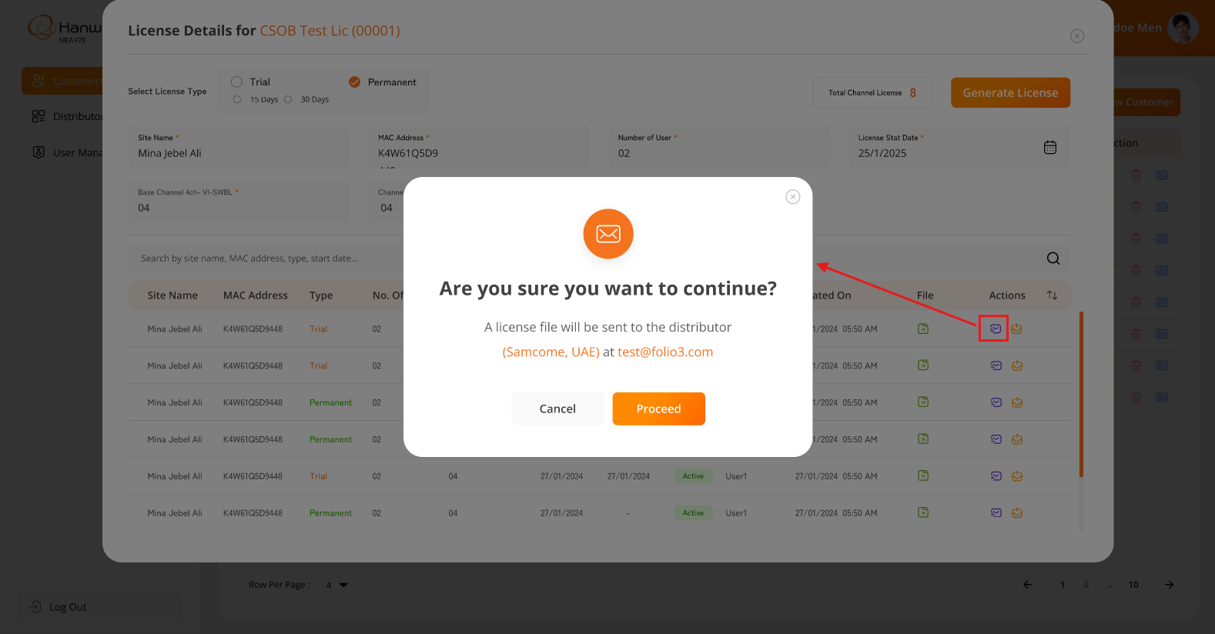

**Business Rules:**

* The system will display information and functionality **strictly as per the attached screenshots**.
* Authorized users will be redirected to this page upon successfully logging into the system.
* This page serves as the landing page after login, accessible only to authorized users.
* Authorized users will have the ability to create and update customers within the system.
* The system will prevent duplicate customer entries.
* A customer cannot be **deleted** if they have at least one active license.
* When a logged-in user attempts to delete a customer, the system will prompt for confirmation. Once confirmed, the system will **soft delete** the customer, meaning the record will remain in the database but will no longer be visible in the web application.
* The "**Add New Customer**" and "**Edit Customer**" screens will include the following fields:
  + Customer Name*
  + Distributor*
  + Email Address*
  + Contact Person*
  + Country*
  + State*
  + City*
  + Postal/Zip Code
  + Mobile*
  + Office Phone
  + Address
* Users can view license details for all generated licenses of a specific customer from the **License Details Modal Popup**.
* The system will allow users to generate a new license with the following two types:
  + Permanent License
  + Trial License (
* The “**Permanent**” license will include following fields:
  + Site Name*
  + MAC Address*
  + Number of Users*
  + License Start Date*
  + Base Channel 4ch-VI-SWBL*
  + Channel License-VI-SW1CH*
* The “**Trial**” license type will include following fields:
  + Duration* (*15 days or 30 days*)
  + Site Name*
  + MAC Address*
  + Number of Users
  + Number of Channels*
  + License Start Date*
* The asterisk (*) indicates a mandatory field only.
* A **Trial License** can be subscribed to for a maximum of **30 days**.
* Users can generate a **maximum of two Trial Licenses** per customer, with a limit of **30 days each**.
* The system will display "**Total License Channels**" before users attempt to generate or upgrade a license.
* The **License Details Modal Popup** will display the “**Customer Name (Customer ID)”** in the title.
  + E.g.

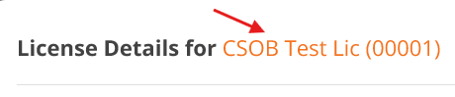

* The list of created licenses will be displayed with the following columns:
  + Site Name
  + MAC Address
  + Type
  + No. Of Users
  + No. Of Channels
  + Start Date
  + End Date (*"-" for Permanent Licenses*)
  + Status
  + Created By
  + Created On
  + File (*with an option to download*)
  + Actions (*Resend & Upgrade*)
* Users can **filter licenses** using:
  + Site Name
  + MAC Address
  + Type
  + Start Date
* Clicking "**Resend**" in the Actions column will send an email to the **associated distributor** with the License file as an attachment.
* Users can download the **license file** directly from the **License Details popup**. The downloaded license file will contain the following information in **encrypted format** to prevent **unauthorized access** or **misuse** in the future. Please find the attached screenshot below for your reference:

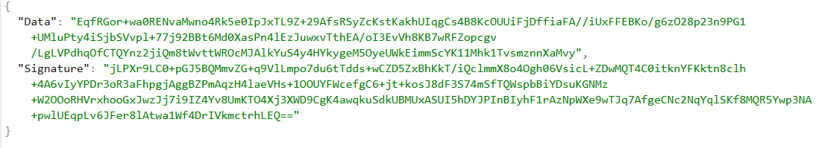

* Clicking "**Upgrade License**" will pre-populate all previous details in the form, allowing users to modify and generate a new license.
* The system will create a **new entry** for the **Upgraded License**.
* Each license is linked to a **specific Site Name and MAC Address**.
* **Permanent Licenses** do not have an expiration date.
* The system maintains the following **license statuses**:
  + Active (*currently in use and authenticated*)
  + Expired (*license is no longer valid*)
  + Future (*created in advance for future use*)
* Users can upgrade an existing license from the **License Details Modal Popup**.
* License files are **encrypted** to prevent unauthorized access.
* A license file is **machine-specific** - it is configured for a particular **MAC Address** ensuring it cannot be used elsewhere.
* The **BI Dashboard Web Application** will have an option to:
  + **Browse and upload a license file along with provided Public Key (***A Public Key will be provided when a new client is created***)** from the local machine.
  + **Validate and authenticate** the license for a specific customer.

**Data Dictionary:**



* The table below will contain details of each **site-wise generated license for the specific customer:**



* The table below will contain details of each **email template:**



# System Architecture

* The image below represents the flow of the **entire system architecture**, including all applications such as the **License Web Application**, **BI Dashboard Web Application**, and the **backend middleware for both applications**:

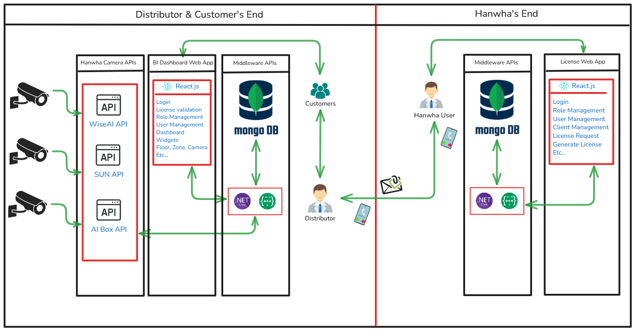

* The architecture below represents the flow of **Backend Development Using .NET Core + Web API**:

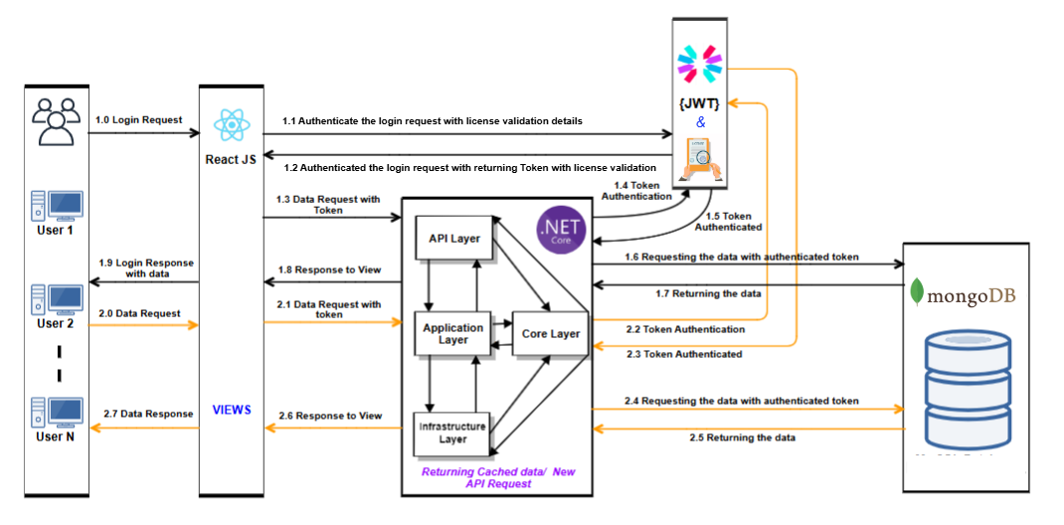

* The architecture below represents the flow of **Frontend Development Using React.js Technology**:

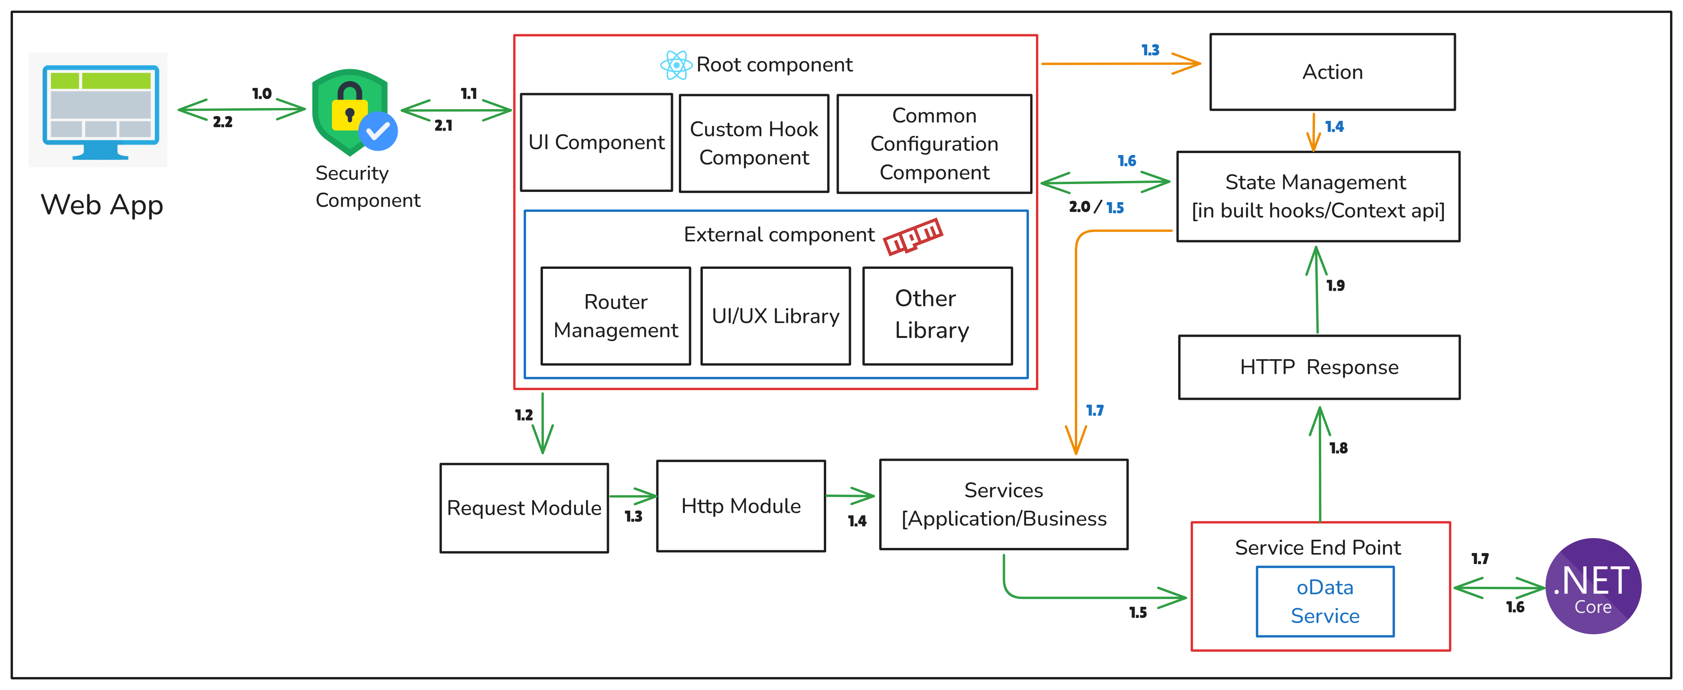

# Assumptions, Dependencies and Constraints

* Any type of Server hosting fees, license cost, any other 3rd party API/SDK fees are not part of  
  development cost and will be procured and paid by client.
  + SPEC will have no liability for hardware failure deployed when running the proposed solution. Hence, the client should only take up relevant issues with the provider for the respective system.
  + Designs showcased in this SRS document as well as the ones shown to the client during the project query discussion calls will be considered as the final designs.
  + SPEC INDIA will not be responsible for any sort of server setup on the client’s UAT or Production Environment.
  + Database administration activities will not fall under the responsibility of SPEC INDIA team.
  + Once the application is live in Production, the database maintenance plan must be configured from the client’s end.
  + SPEC INDIA will not be responsible for any Point-in-Time Database Recovery/DR Drill/Database Upgrade/ Maintenance tasks etc.
  + The details are prepared based on the client's discussion; hence, changes may be made after completing the requirements study, which may require discussions under the change management process.
  + Any delay in the project schedule due to decision-making, data gathering, or approvals from the client side should be handled at the client's side. SPEC INDIA won’t be responsible for adding more resources for early completion in such scenarios.
  + The warranty period will automatically start ten days after the UAT rollout of both the applications (Client Web App & License Web App) & the **warranty period will be 3 months**.
  + After warranty completion, extra charges will be charged for knowledge transfer or documentation for/to another vendor.
  + The client will own the developed product and source code submitted after the final milestone payment.
  + A delay during any phase of the project by the customer will not be considered a delay by SPEC INDIA, and any payment milestone will not be delayed due to it.
  + Any delay in providing feedback or required dependency for more than two weeks will be escalated by SPEC INDIA.

# Signature: SRS Document Sign-Off Sheet

**IVTECH COMPUTER SYSTEMS LLC** and **SPEC INDIA** hereby acknowledge that they have reviewed and understood this Software Requirement Specification (SRS) document. Upon signing by the Authorized Representatives of both parties, they mutually agree to adhere to its defined scope and requirements. The signatures below indicate acceptance of this SRS document as the final version.

|  |  |  |
| --- | --- | --- |
| Company (Team) | Authority | Signature / Mail Approval Attachment |
| For SPEC INDIA | **Milind Shroff** |  |
| IVTECH COMPUTER SYSTEMS LLC | **Mr. Prateek Bhardwaj** |  |

#### ---- end of document ----